Pre Annual Review

Parent/carer Contribution

Year 9 and above

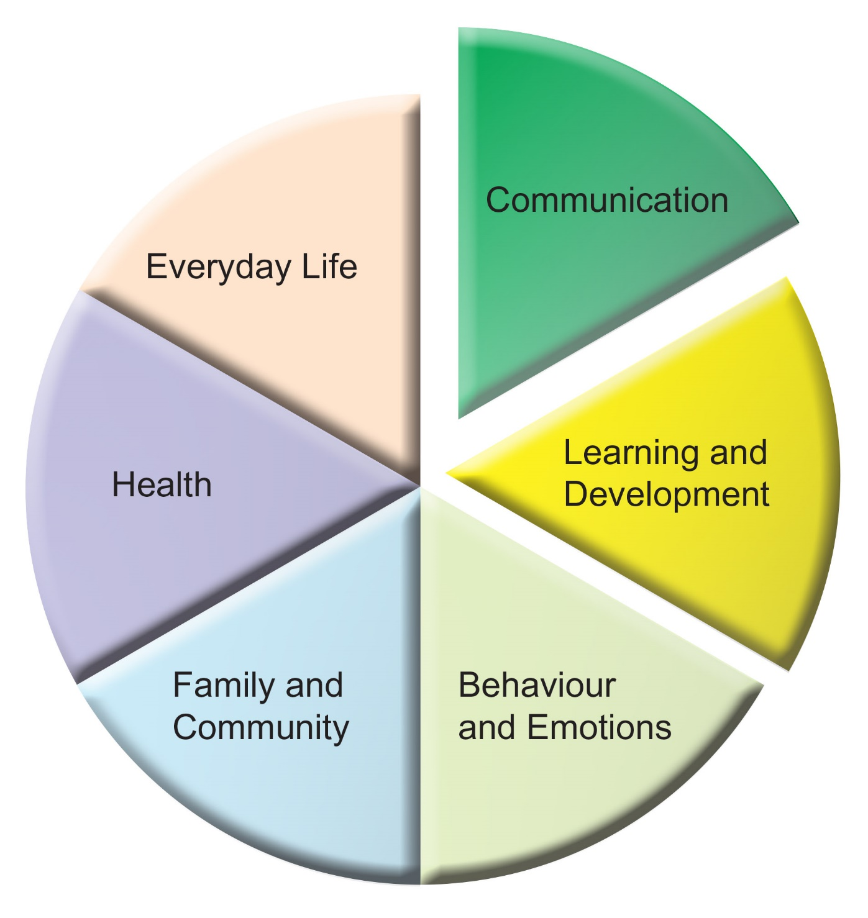



**Family Contribution**

**Our contribution to our child’s Annual Review Meeting**

Child’s name       Date of Birth

School       Date of meeting

Please confirm your address below:

|  |
| --- |
| What do you like and admire about your child? |

|  |
| --- |
| What do you consider to be your child’s achievements over the year? |

**What do you think is working well at home or school?**

|  |  |  |
| --- | --- | --- |
|  | **Home** | **School** |
| **Communication** |  |  |
| **Learning and Development** |  |  |
| **Behaviour and Emotions** |  |  |
| **Health** |  |  |
| **Everyday Life** |  |  |
| **Family and Community** |  |  |

**What do you think could have gone better at home or school?**

|  |  |  |
| --- | --- | --- |
|  | **Home** | **School** |
| **Communication** |  |  |
| **Learning and Development** |  |  |
| **Behaviour and Emotions** |  |  |
| **Health** |  |  |
| **Everyday Life** |  |  |
| **Family and Community** |  |  |

|  |
| --- |
| **What is important for your child at home and school?** |

|  |  |
| --- | --- |
| **What are your hopes and aspirations for your child’s future?**  ***(It would be very useful if you could jot down your thoughts and ideas)*** | |
| **Employment and learning** |  |
| **Independent Living** |  |
| **Good health** |  |
| **Friendships,**  **Relationships**  **and Community** |  |
| **Anything else you wish to share?** |  |

|  |
| --- |
| **What help do you think your child will need to achieve these and from whom?** |

Name

Signature       Date

***Thank you.***

***Please send this back to the school.***