Preparing for Adulthood

*Annual Review Contribution: Pupil*

*Year 9 and above*

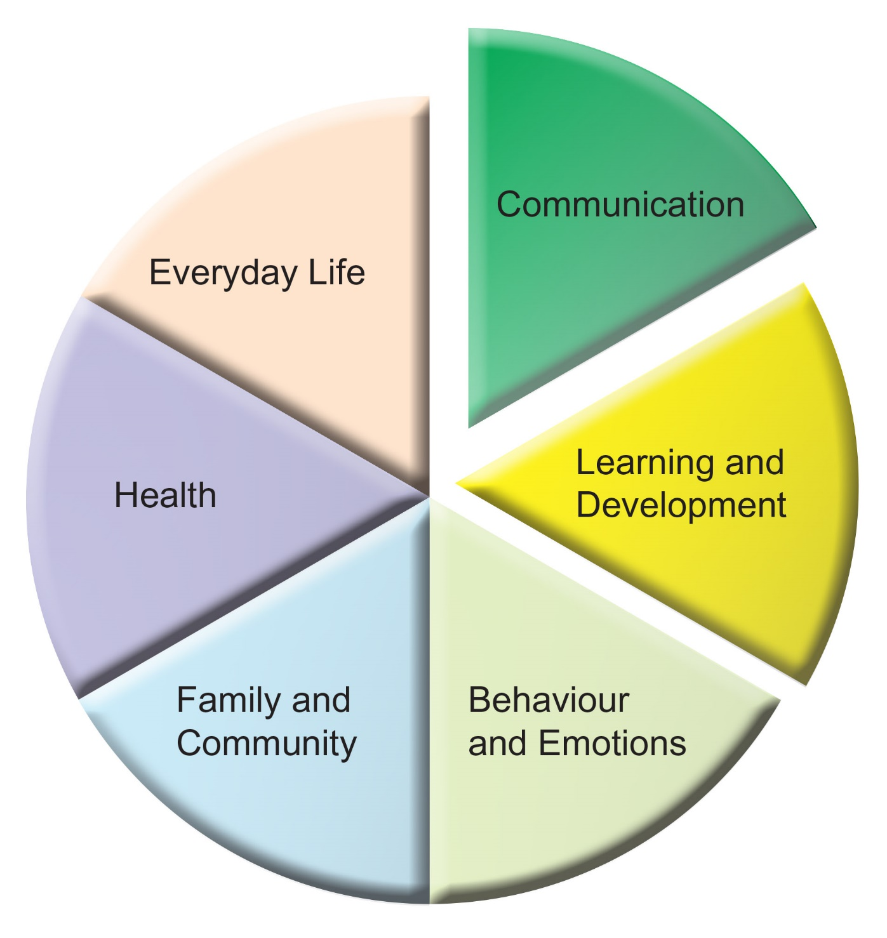



**Preparing for adulthood**

We’re are encouraging all young people to start planning their future from an early age. From Year 9 onwards this is particularly important, as we want you to be supported to consider their hopes and aspirations for different areas of adult life.

**FOR SCHOOLS:** This form should be used for young people in Y9 and above to record their opinions and should be returned to the Local Authority following their Annual Review, along with the ‘Summary of Annual Review Meeting’.

**Name of Young Person ...........................................................................**

**Date of Birth .............................................................................................**

|  |  |
| --- | --- |
| Employment and Learning  *(Future learning, College, Apprenticeships, University, Internships, Work experience, careers guidance, supported employment, access arrangements, vocational interests)* | |
| What are your goals and aspirations? | What are you able to do at the moment? |
| What needs to happen next for you to achieve your goals and aspirations? | |

|  |  |
| --- | --- |
| Independent Living  *(Who to live with, where to live, independent travel, managing money, daily living skills)* | |
| What are your goals and aspirations? | What are you able to do at the moment? |
| What needs to happen next for you to achieve your goals and aspirations?  If you have a social worker, remember to talk to them about this too | |

|  |  |
| --- | --- |
| Health  *(Mental health, emotional wellbeing, physical health, medication and therapies, services and specialists, healthy eating, exercise and activity)* | |
| What are your goals and aspirations? | What are you able to do at the moment? |
| What needs to happen next for you to achieve your goals and aspirations?  Some Health services may change when you are 18. Please make sure that you check this information with your key health professional | |

|  |  |
| --- | --- |
| Community Inclusion: Friendships, Relationships and Community  *(Friendships, relationships, family, socialising, hobbies and interests, travel and transport, where to live, who to live with)* | |
| What are your goals and aspirations? | What are you able to do at the moment? |
| What needs to happen next for you to achieve your goals and aspirations? | |

|  |
| --- |
| Is there anything else you want to tell us about? |
|  |
| Did you have support to complete this form?  If so, who helped you |
|  |

*More information available at:*

*www.gettingalife.org.uk*

[*www.preparingforadulthood.org.uk*](http://www.preparingforadulthood.org.uk)

**Ask your school/college about what careers guidance you can access!**