I want to tell you………

…what is important to me and what I think.

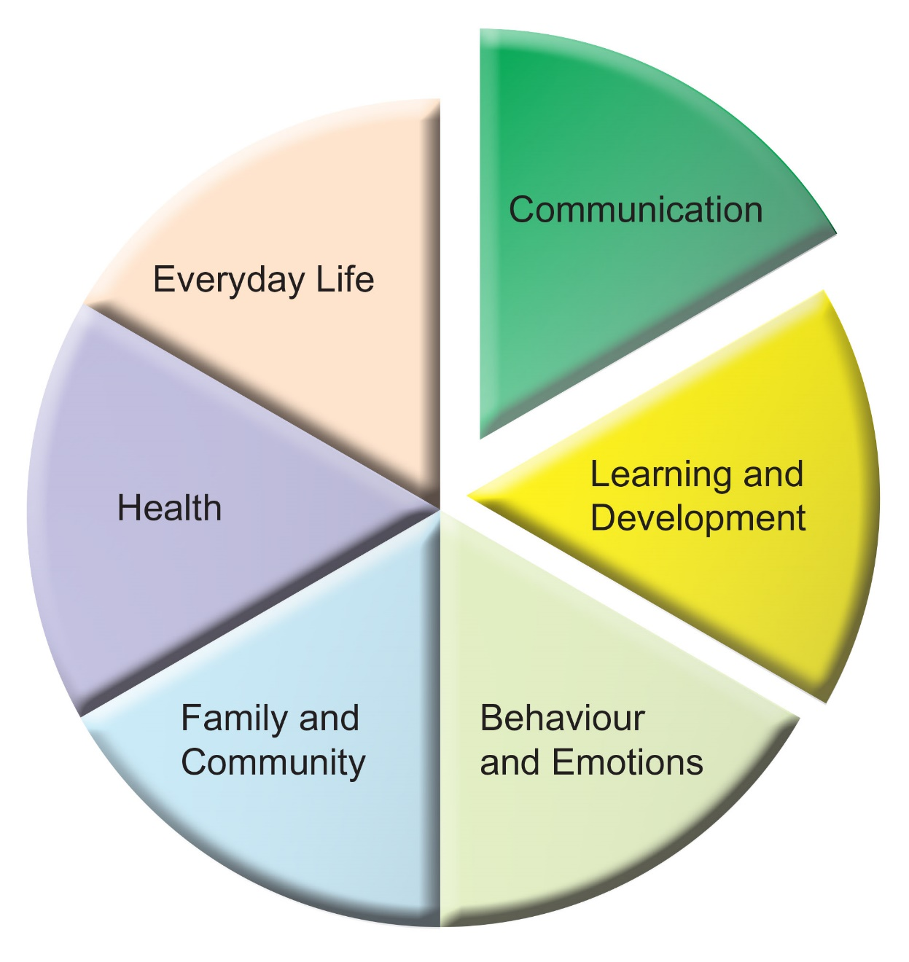

_________________________________________________________________

Name……………………………………………………………………………………………...

Date of Birth………………………………………………………………………………………

Address…………………………………………………………………………………………………………………………………………………………………………………………………..

Parents/Young Person’s

Preferred contact details………………………………………………………………………..

**Initial EHC request paperwork**

I want to tell you………

…what is important to me and what I think.

Guidance for the adult supporter

This booklet should be used to ensure the child or young person has a chance to say what they think is important to them. It will form an important part of any future decision-making and planning.

This is not an assessment or judgement. It should paint a picture of the child or young person at school, within their family and their community.

It is split into **Myself, My School, My Home,** but will cover the following areas:

* Communication
* Development and Learning
* Behaviour and Emotions
* Health
* Everyday Life
* Family and Community

Your child or young person does not have to fill in everything. Please take your time, perhaps involve others. Your child or young person may wish to fill this in themselves in words, pictures or symbols or they may want to talk it through and let someone else write it down.



What I like best

about myself

and

what others like about me

*put your*

*own words in the stars*

This is me …

|  |
| --- |
| How do you tell people what you want? |
|  |

|  |
| --- |
| What are your proudest achievements? |
|  |

|  |
| --- |
| What would you like to be able to do in the future? |
|  |

Friends

My School …

|  |
| --- |
| What are you good at? |
|  |

|  |
| --- |
| What do you enjoy about being in school? |
|  |

|  |
| --- |
| Is there anything in school you don’t like or find difficult? |
|  |

|  |
| --- |
| What do you find helpful in school? |
|  |

|  |
| --- |
| What would you like to be able to do in the future? |
|  |

|  |
| --- |
| How do you like to learn? |
|  |

|  |
| --- |
| Is there anything else that would help you to learn? |
|  |

|  |
| --- |
| Is there anything else you would like to tell us? |
|  |

My Home Life…….

|  |
| --- |
| Who are the people that live with you? |
|  |

|  |
| --- |
| What do you like doing in your spare time? |
|  |

Thank you for taking the time to give us your thoughts…..they are very important to us.

We would now like to share this booklet with other people who know you and support you. We want to make sure everyone knows how best to help you so that you can achieve the very best you can.

