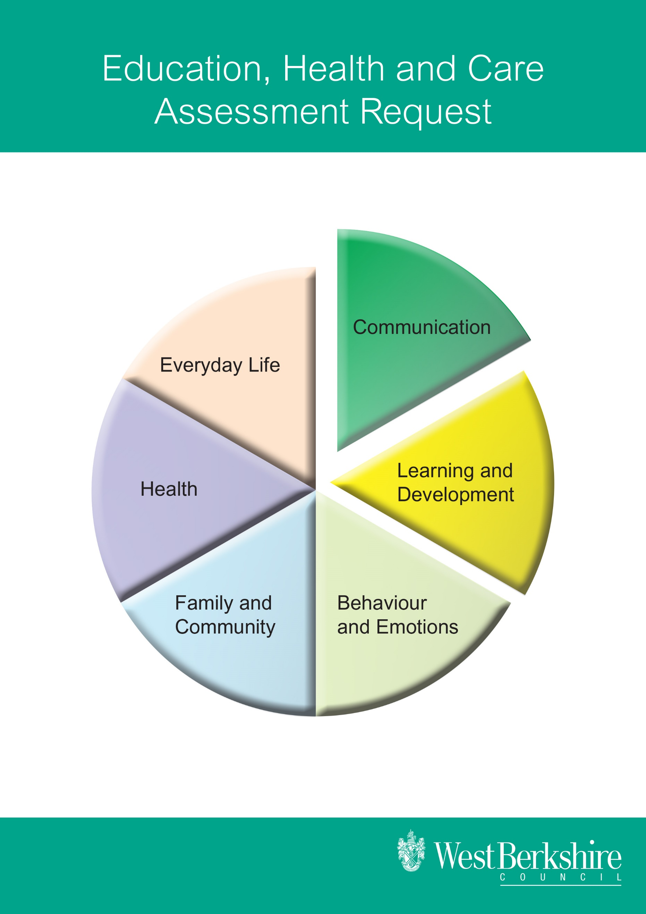

**Request for an Education, Health and Care Assessment**

*NB: Education, Health and Care will be referred to as EHC throughout this assessment document*

**Contents**

Section A: Child’s or young person’s details

Section B: Family details and Social Care involvement

Section C: Evidence of the child’s or young person’s strengths and difficulties

Section D: Current provision

Section E: Views and advice

Section F: Consent

**All sections of the form should be completed**

**Section A: Child or young person’s details**

|  |  |  |  |  |  |
| --- | --- | --- | --- | --- | --- |
| Surname : |  | | | | |
| First name(s): |  | | | | |
| Known as: |  | | | | |
| Date of birth: |  | | | | |
| Age: |  | | | | |
| School Year Group  Please state if Offset |  | | | | |
| Gender: | Male | | | Female | |
| Address: |  | | | | |
| Preferred contact details for young person over 16: | Tel: |  | | | |
| Email: |  | | | |
|  |  | | | | |
| Educational placement attended by the child or young person |  | | | | |
| Date the pupil started at the educational placement: |  | | | | |
|  | | | | | |
| **Previous educational placements** | | | | | |
| **Placement:** | | | **Date from:** | | **Date to:** |
|  | | |  | |  |
|  | | |  | |  |
|  | | |  | |  |
|  | | |  | |  |

**Section B: Family details**

|  |  |  |  |  |  |  |  |
| --- | --- | --- | --- | --- | --- | --- | --- |
| **Details of parent/carer with whom the pupil normally lives:** | | | | | | | |
| Title/s: | | | |  | | | |
| First name/s: | | | |  | | | |
| Surname/s : | | | |  | | | |
| Relationship to child / young person: | | | |  | | | |
| Home address: | | | |  | | | |
| Tel: | | Home | |  | | | |
|  | | Work | |  | | | |
|  | | Mobile | |  | | | |
| Preferred contact number: | | | |  | | | |
| Email: | | | |  | | | |
| How would you like to be contacted? | | | |  | | | |
|  | | | | | | | |
| **Details of other parents/carers** | | | | | | | |
| Title: | | | |  | | | |
| First name/s: | | | |  | | | |
| Surname/s: | | | |  | | | |
| Relationship to child /young person | | | |  | | | |
| Home address: | | | |  | | | |
| Tel: | | Home | |  | | | |
|  | | Work | |  | | | |
|  | | Mobile | |  | | | |
| Preferred contact number: | | | |  | | | |
| Email: | | | |  | | | |
| How would you like to be contacted? | | | |  | | | |
| **Details of other parents/carers** | | | | | | | |
| Title/s: | | | |  | | | |
| First name/s: | | | |  | | | |
| Surname/s: | | | |  | | | |
| Relationship to child / young person: | | | |  | | | |
| Home address: | | | |  | | | |
| Tel: | | Home | |  | | | |
|  | | Work | |  | | | |
|  | | Mobile | |  | | | |
| Preferred contact number: | | | |  | | | |
| Email: | | | |  | | | |
| How would you like to be contacted? | | | |  | | | |
|  | | | | | | | |
| **Please list the names of the people who have parental responsibility for this child/young person** | | | | | | | |
|  | | | | | | | |
|  | | | | | | | |
| **Other children living in the household and their relationship to the child / young person** | | | | | | | |
| **Title** | **Given name** | | **Family name** | | | **Relationship to child / young person** | |
|  |  | |  | | |  | |
|  |  | |  | | |  | |
|  |  | |  | | |  | |
|  | | | | | | | |
| **Other adults living in the household and their relationship to the child / young person** | | | | | | | |
| **Title:** | **Given name** | | **Family name** | | | **Relationship to child / young person** | |
|  |  | |  | | |  | |
|  |  | |  | | |  | |
|  | | | | | | | |
| **Other factors** | | | | | | | |
| Are parents/carers in the armed forces? | | | | | Yes | | No |
| Language spoken at home | | | | |  | | |
| Is an interpreter needed? | | | | | Yes | | No |
| If so, what language? | | | | |  | | |
| Does a parent/carer have a disability? | | | | | Yes | | No |
| Are any special arrangements needed? | | | | |  | | |
| Religion | | | | |  | | |

|  |  |  |  |
| --- | --- | --- | --- |
| **Social care involvement** | | | |
| Is the child/young person known to social care / adult services? | Yes | No | |
| Is the child/young person the subject of a Child Protection Plan? | Yes | No | |
| Is the child/young person looked after by the local authority? | Yes | No | |
| Is the child/ young person subject to a Care Order, or any other order? | Yes | No | |
| If yes, please expand below. | | | |
| **Type of Care Order** | | | **Date granted** |
|  | | |  |
|  | | |  |
|  | | |  |
| Name and contact details of social worker (if applicable) |  | | |
| Responsible Social Services authority |  | | |

**Section C: Evidence of the child’s or young person’s strengths and difficulties**

What do you consider the child’s / young person’s primary and additional Special Educational Needs / difficulties to be?

|  |  |
| --- | --- |
| **Primary SEN:** |  |
| **Additional needs:** |  |

**Observations/other evidence of the child /young person’s strengths and difficulties**

|  |  |
| --- | --- |
| **Communication** | |
| Strengths |  |
| Difficulties |  |
| Outcome  (What do you hope the child or young person will achieve in the next 2-3 years in this area?) |  |

|  |  |
| --- | --- |
| **Learning and Development** | |
| Strengths |  |
| Difficulties |  |
| Outcome  (What do you hope the child or young person will achieve in the next 2-3 years in this area?) |  |

|  |  |
| --- | --- |
| **Behaviour and Emotions** | |
| Strengths |  |
| Difficulties |  |
| Outcome  (What do you hope the child or young person will achieve in the next 2-3 years in this area?) |  |

|  |  |
| --- | --- |
| **Health** | |
| Strengths |  |
| Difficulties |  |
| Outcome  (What do you hope the child or young person will achieve in the next 2-3 years in this area?) |  |

|  |  |
| --- | --- |
| **Everyday Life** | |
| Strengths |  |
| Difficulties |  |
| Outcome  (What do you hope the child or young person will achieve in the next 2-3 years in this area?) |  |

|  |  |
| --- | --- |
| **Family and Community** | |
| Strengths |  |
| Difficulties |  |
| Outcome  (What do you hope the child or young person will achieve in the next 2-3 years in this area?) |  |

**Standardised tests administered by the school, including standardised reading scores and spelling scores and National Curriculum attainment.**

|  |  |  |  |
| --- | --- | --- | --- |
| **Name of test** | **Date of testing** | **Chronological age at time of testing**  **(years/months)** | **Test result/scores** |
|  |  |  |  |
|  |  |  |  |
|  |  |  |  |
|  |  |  |  |

**Section D: Current provision**

What provision have you been making for the child from within your designated SEN budget up to at least the equivalent of £6,000 per annum. Provision **ONLY** includes 1:1 work, small group work, specific equipment and interventions.

Please note resources must be additional to the provision for all children or young people. If the child or young person is working in a group, cost must be split between all the members of the group.

For a child under compulsory school age attending an early setting please give details of additional support provided by the nursery/SEN Pre-School Funding/ Early Years Funding.

For a young person attending further education, please give details of additional support provided from element 1 and element 2 funding equating to £10,000.

Please record the most recent intervention first.

|  |  |  |  |  |
| --- | --- | --- | --- | --- |
| **Provision**  **(Including frequency, duration, size of group etc)** | **Costings** | **Impact** | **Date started** | **Date ended** |
|  |  |  |  |  |
|  |  |  |  |  |
|  |  |  |  |  |
|  |  |  |  |  |

**Section E: Views and advice**

Reports /documents which **must** be attached.

|  |  |
| --- | --- |
| **Advice / views sought from** | **Date(s) attached reports/documents were completed** |
| Educational Psychologist |  |
| Three most recent Support and Achievement Plans including the reviews |  |

*N.B. Permission must be obtained from the author of each attached report and reports more than 12 months old should not normally be included.*

Additional advice which you may have sought:

| **Advice sought from:** | **Please tick as appropriate** | **Date of recent report if attached** |
| --- | --- | --- |
| Advisory Teacher for Autistic |  |  |
| Therapeutic Thinking Team |  |  |
| Child and Adolescent Mental Health Service |  |  |
| Cognition and Learning Team |  |  |
| Community Paediatrician |  |  |
| Early Development and Inclusion Team |  |  |
| Emotional Health Academy |  |  |
| Ethnic Minority and Traveller Achievement Service |  |  |
| Occupational Therapist |  |  |
| Physiotherapist |  |  |
| Specialist Inclusion Support Service |  |  |
| Speech & Language Therapist |  |  |
| Teacher of the Deaf |  |  |
| Teacher of the Visually Impaired |  |  |
| Other (please specify) |  |  |
| Other (please specify) |  |  |

**Section F: Consent**

|  |  |  |  |
| --- | --- | --- | --- |
| **Headteacher /Principal signature** | | | |
| **Signed** |  | **Date** |  |
| *I have discussed the EHC application with the parent(s)/carer(s) of the child or young person, and the child or young person where appropriate, and they support us in making this application.* | | | |
| **Parents’/carers’ signatures** | | | |
| **Signed** |  | **Date** |  |
| *I have discussed and understood the EHC application and give my consent for this to proceed. I give my permission for this application to be shared with the agencies involved in the EHC assessment.* | | | |
| **Where applicable, child/young person’s signature** | | | |
| **Signed** |  | **Date** |  |
| *I have discussed and understood the EHC application and give my consent for this to proceed. I give my permission for this application to be shared with the agencies involved in the EHC assessment.* | | | |

**The completed EHC application should be emailed both as a word (.doc) document and a scanned copy containing the signatures in section F to the case officer for your school:**

[SenAssessmentTeam@westberks.gov.uk](mailto:SenAssessmentTeam@westberks.gov.uk)

**Please also make sure you have attached scanned copies of all relevant additional documentation.**