Emotions Parents May Go Through
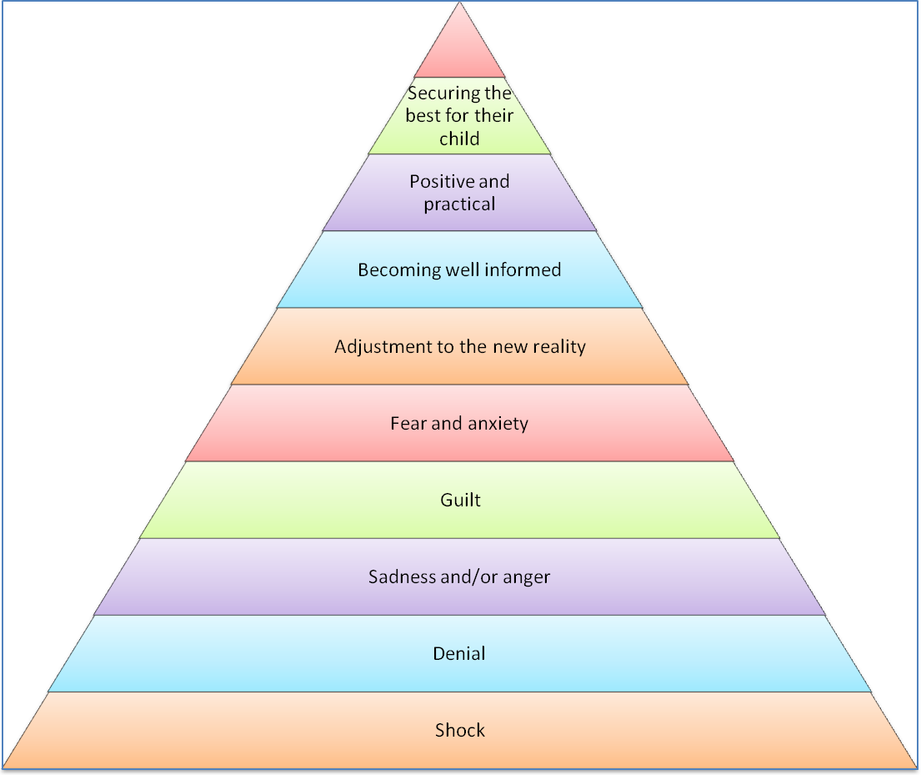
Some parents may go through all or parts of the range of feelings

The diagram outlines some of the ways parents may be feeling at any given moment . Where parents are on the diagram (if they are there at all) will vary at different times dependingupon the circumstances.
Shock: When some parents hear or realise that their child has a special/additional nees the feelings that may have at that moment is one of complete shock. Such news may come like a bolt from the blue and parents can be stunned and upset. For some parents this news is given after birth and for others much later when a childs is diagnosed by a paediatrician or other specialist.
Denial: parent smay initially reject any professional opinion and refuse to accept it. Advice may be sought from many different sources by parents who are looking for an explanation as to why professionals seem to be ‘labelling’ theire child. Some time may pass before parents accept that there may be difficulties ahead.
Sadness and/or anger: Parents may feel immense grief and sadness when they realise that their child may have a special/additonal need. They may feel enraged that this could be their own reality for the forseeable future and that things have not gone as they planned. These feelings can be exasperated by the struggle many parents have to achieve the best possible care and education ofr their child.
Guilt: Often parents feel that they are to blame for any difficulties their children may experience, although this is seldom the case in reality. They may reproach themselves for not notising things sooner or feel guilty about having to leave their child in hospital or even at the pre-school.
Fear and anxiety: It is often with trepidation that many parents approach any new situation. How will tthey care for their child? Will the pre-school be able to meet their child’s needs? What will the future hold for their child?
Anxiety may make parents apprehensive about leaving their child. It may make parents feel nervous and look for reassurance that practitioners understand and can cope with the needs of their child.
Adjustment to the new reality: Parents, who, as all practitioners realise, know their child better than anyone, may have had concerns and worries about their child over a long period of time, Having a clearer understanding of their child’s needs outlined b a doctor or other professional often comes as a relief to many parents. Once they know what they are dealing with they can start to readjust to their situation. This readjustment often will affect the whole family including grandparents, aunts and uncles as well as siblings.
Become well informed: Parents of a child with a special or additional need frequently become extremely well informed about their child’s condition. They themselves can become experts. Paretns can often make the huge efforts needed to become well informed to help meet the challenges of and give the best possible care and attention to their child.
Securing the best for their child: All parents ~ particularly the parents of children with special/additional needs ~ want the best possible start for their child. In attempting to secure this, parents may often be perceived by practitioners as demanding. Through working closely together in partnership practitioners will begin to realise that parental inpur is vital to ensure a child with special/additional needs reaches their own potential.
Parents know their child best. They understand their child and the challenge ofr many parents once their child goes to pre-school is to bring practitioners ‘on board’. Practitioner who are prepared to consult with and learn from the parents’ help provide the best possibl;e start for any child with special/additional needs.
Respect for families and a non-judgemental attitude
At the heart of any positive working relationship lies a genuine respect for the families of the children in your setting. It recognises that the family, and parents in particular, are the most important element in a child’s life.
Sometimes this is hard to do when parents are perceived as being demanding of a practitioner’s time and energy. However, basic human respect and professionalism are at the very core of care and education. All early years practitioner are in the profession because of a desire to help achieve the best possible start for the children in their care.
Being non-judgements involves thinking positively about paretns, regardless of their personal charateristics, child rearing practices or situation. It requires a practitioner to believe that parnets have fundmental desire to do the best ofr their child.
A non-judgemental and respectful practitioner communicates confidence that the parents are managing often difficult situations well. The main beneficiary of this positive is always the child.

