Appendices



Additional information from Early Years settings…………………………………………………………………. 3  
Speech and Language Intervention Tracker………………………………………………………………………. 4  
Attention Autism………………………………………………………………………………………………………..5  
Blanks Levels of Questioning…………………………………………………………………………………………7  
Word Map………………………………………………………………………………………………………….…....8  
Typical Development of Speech Sounds………………………………………………………………………….... 9  
Intensive Interaction Checklist………………………………………………………………………………………. 11  
PECS Reinforcer Handy Hints………………………………………………………………………………………. 16



**Early Years Speech and Language Therapy Service**

***Additional information from early years settings***

Dear parent / carer. You can access advice from the Early Years Speech and Language Therapy service. Please send an email to your local team.

**Wokingham** - [CYPIT.ADMINBRWOK@berkshire.nhs.uk](mailto:CYPIT.ADMINBRWOK@berkshire.nhs.uk)

**Reading** - [CYPIT.ADMINREADING@berkshire.nhs.uk](mailto:CYPIT.ADMINREADING@berkshire.nhs.uk)

**West Berkshire (Newbury)** - [CYPIT.ADMINNEWBURY@berkshire.nhs.uk](mailto:CYPIT.ADMINNEWBURY@berkshire.nhs.uk)

Please include your child’s name and date of birth or NHS number, a contact telephone number and information about the day of the week that works best for the team to contact you. If your child’s nursery has provided some information below, please attach this to the email.

A speech and language therapist will call you as soon as they can.

|  |  |  |  |
| --- | --- | --- | --- |
| **Child’s name:** | **Date of birth / NHS Number:** | | **Name of early years setting:** |
| What are you hoping for from early years speech and language therapy service? | | | |
| How is the child’s speech, language and communication skills affecting them on a day to day basis? | | | |
| What additional support has been put in place? | | How has the child responded to this? | |
| **Please provide the details of the key person (at your setting) who we can liaise with:** | | | |
| Name: | | Role: | |
| Telephone number:  Best day / times to ring: | | Email address: | |

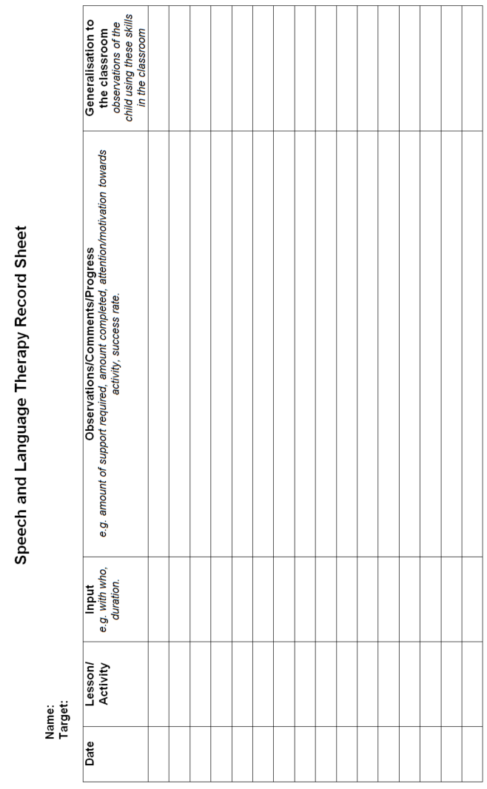

|  |  |
| --- | --- |
| **Appendix 3: Attention Autism**  **Stage 1 – Gaining Attention**  The aim: To achieve a child’s shared attention willingly  [Image result for bucket with lid](https://www.google.co.uk/url?sa=i&rct=j&q=&esrc=s&source=images&cd=&cad=rja&uact=8&ved=0ahUKEwiindTQupjYAhUGb1AKHdO3DMUQjRwIBw&url=https://www.ebay.co.uk/p/14l-Plastic-Nappy-Bucket-With-Lid-and-Handle-3-Gallon-Baby-Bin-Storage-Container-Cream/1362924170&psig=AOvVaw1uOQj6pD1z7W2BdZdhIU5V&ust=1513854759646022)**The Bucket**   * Support the child to transition with visual prompt (whiteboard) * Supporting adults model positive behaviour – If you’re in the room, you cannot ‘opt out’ * Sing ‘Bucket song’ * Model 3 adult-led motivating activities | **Stage 2 – Sustain Attention**  The aim: To achieve sustained attention to an adult-led activity  e.g. **Flour Shaking**  Image result for flour shaking through sieve   * Keep language at a minimum – model key words only * The child should watch the activity from start to finish, including set up and tidy up * Take time to admire your creation before packing away |
| **Stage 3 – Turn Taking**  Aim: To be able to watch, participate and re-engage.  To tolerate when it is not your turn.  [Image result for sat under a see through umbrella](https://www.google.co.uk/url?sa=i&rct=j&q=&esrc=s&source=images&cd=&cad=rja&uact=8&ved=0ahUKEwjhqueixZjYAhXQJ-wKHZ2RANEQjRwIBw&url=https://www.target.com/p/shedrain-bubble-umbrellas-clear/-/A-49152482&psig=AOvVaw3Cb80XkkBoBQWo1MNqsWKf&ust=1513857492814290)e.g. **Umbrella**   * Leading adult chooses who gets a turn, model the activity with a supporting adult first * Model that turn-taking opportunities are limited and sometimes we won’t get a turn * Keep language at a minimum – model key words only | **Stage 4 – Table Top Activity**  Aim: To observe, transition to a workstation and complete an independent activity  e.g. **The Box**  [Image result for plastic takeaway box](https://www.google.co.uk/url?sa=i&rct=j&q=&esrc=s&source=images&cd=&cad=rja&uact=8&ved=0ahUKEwiWlp7LxpjYAhUL6aQKHX7jA4wQjRwIBw&url=https://www.cater4you.co.uk/acatalog/285-650cc-clear-plastic-container-and-lid.html&psig=AOvVaw3s5b2DjYlk8t69yiJ2zzpD&ust=1513857963890579)     * Leading adult demonstrates activity to the group * A box of supplies is provided for each child and supporting adult * Children are supported to transition to a workstation and complete same activity * Children come back together in a group to share their success! |

|  |  |
| --- | --- |
| **Stage 4** | **Juggling Balls** – *Wrap a handful of uncooked rice in cling film to make a ball. Cut the ends off two balloons. Put the ball of rice inside one balloon. Use the second balloon to cover the hole.*  **Build a tower** – *Put coloured blocks and a corresponding pattern for the children to copy in each box. Build the tower and knock them down!*  **Playdoh Creatures/Faces** – *Provide pipe cleaners, feathers, jewels, sequins, etc for decoration.*  **Paper plate Creatures/Masks** - *Provide pipe cleaners, feathers, jewels, sequins, etc for decoration.* |
| **Stage 3** | **Umbrella** – *Have the child sit and hold the umbrella over them. Drop glitter/sequins for ‘rain’ and cotton balls for ‘snow’.*  **Handprint tree** – *paint hands and print the ‘leaves’ of a tree.*  **‘Day at the beach’** – *Fill a row of trays with rocks, shells, sand, water and place a towel at the end. Take off shoes and experience a ‘day at the beach’.*  **Parachute** – *Sit/Lie the child beneath the parachute while singing ‘the parachute goes up and down…’ to the tune of ‘wheels on the bus’*  **Flour shaking** *– see stage 2*  **Marble run** *– see stage 2*  **Jump off a chair/step** – *Ready… Steady… Jump!*  **Crawl through a tunnel** |
| **Stage 2** | **Flour shaking** - *shake flour over stencilled shapes and reveal them.*  **Rainbow** *– Create a row of multi-coloured paints on a sponge and print a rainbow.*  **Cake Splat!** *– Present silicone cupcake cases and fill each one with shaving foam. Spray food colouring and ‘decorate’. Splat! them one by one.*  **Marble run** *– Build marble runs of varying shapes/sizes.*  **Flour Castles** *– Use a small container to make sandcastles. Decorate with flags, feathers, etc. Knock them down!*  **Volcano Eruption** *– Mix baking soda and vinegar in a container.* |

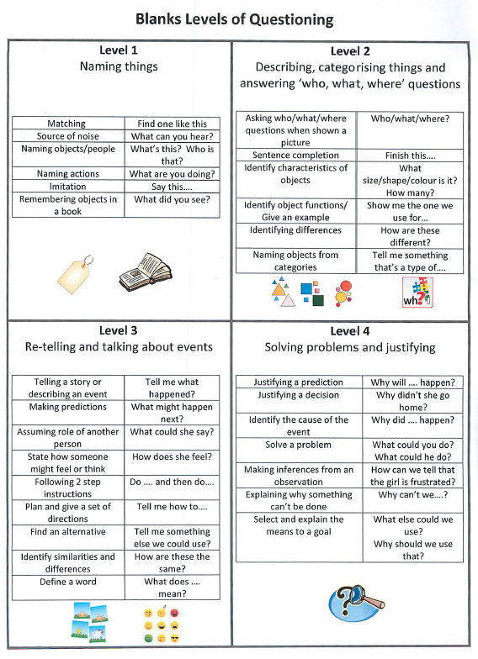**Appendix 4: Blanks Levels of Questioning**

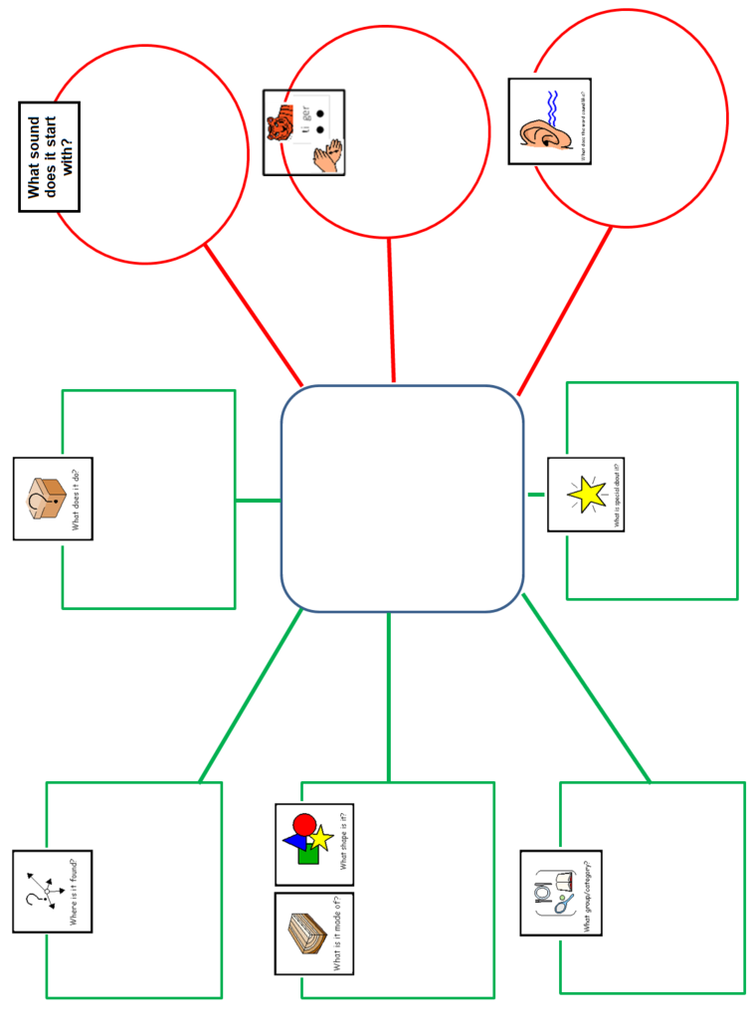**Appendix 5: Word Map**

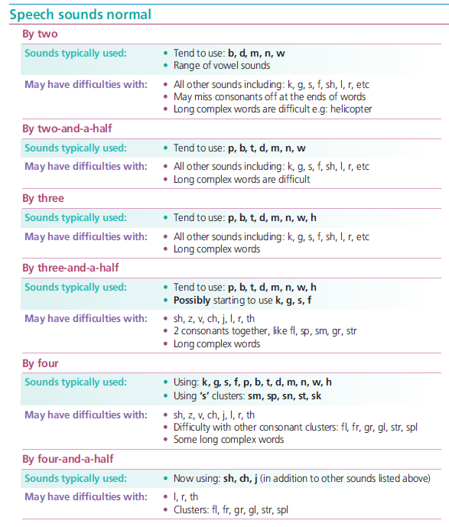**Appendix 6: Typical development of speech sounds**

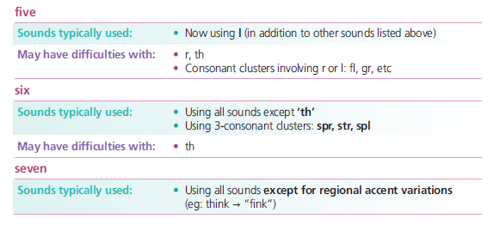

**Appendix 7: Intensive Interaction Checklist**

**Name of Client:** ______________________________  **DoB:** ___________________

**Completed by:** ______________________________ **Date:** ___________________

**Location of Session:** __________________________ **Length of Session:** ________

**1. Looking and Eye Contact**

|  |  |  |
| --- | --- | --- |
| 1. | Child averts eyes from adult |  |
| 2. | Child gives fleeting gaze to adult when they make exaggerated movements and noises |  |
| 3. | Child gives sustained gaze when adult makes exaggerated movements and noises |  |
| 4. | Child tracks adult when the make exaggerated movements and noises |  |
| 5. | Child gives fleeting eye contact when adult makes exaggerated movements and noises |  |
| 6. | Child gives sustained eye contact when adult makes exaggerated movements and noise |  |
| 7. | Child gives fleeting eye contact to request more of adults actions |  |
| 8. | Child gives sustained and alternated eye contact to continue interaction |  |
|  | Additional comments: |  |

**2. Enjoyment of Engaging with Another Person**

**2.1 Child’s responses to Adult**

|  |  |  |
| --- | --- | --- |
| 1. | Tolerates adult within room when child is engaged |  |
| 2. | Tolerates adult within play space |  |
| 3. | Tolerates adult playing alongside |  |
| 4. | Tolerates adult joining in with their play |  |
| 5. | Tolerates increasing person to person engagement with adult |  |
|  | Additional comments: |  |

**2.2 Child Initiated**

|  |  |  |  |
| --- | --- | --- | --- |
| 1. | Initiates engagement by placing themselves next to adult | |  |
| 2. | Initiates engagement by physical means e.g. holding out hand | |  |
| 3. | Initiates engagement by eye contact | |  |
| 4. | Initiates engagement by vocalizing | |  |
| 5. | Initiates engagement by use of speech/symbol/photo/OOR | |  |
|  | If yes, How? | | |
| 6. | Requests repeat of engagement |  | |
|  | Additional Comments: | | |

**3. Turn-Taking**

**3.1 Child’s Response**

|  |  |  |  |  |  |
| --- | --- | --- | --- | --- | --- |
|  |  | How? | | | |
|  |  | Physical | Eye Contact | Vocalising | Other |
| 1. | Reacts to adult when copied |  |  |  |  |
| 2. | Reflects back to adult for one turn |  |  |  |  |
| 3. | Reflects back to adult for increasing number of turns in sequence |  |  |  |  |
|  | Additional Comments: | | | | |

**3.2 Child Initiated**

|  |  |  |  |  |  |
| --- | --- | --- | --- | --- | --- |
|  |  | How? | | | |
|  |  | Physical | Eye Contact | Vocalising | Other |
| 1. | Initiates interaction in structured and predictable context, and waits briefly for response *(e.g. adult waiting expectantly with hand held out)* |  |  |  |  |
| 2. | Initiates interaction with adult looking expectantly, and waits briefly for response |  |  |  |  |
| 3. | Initiates interaction spontaneously and waits briefly for response |  |  |  |  |
| 4. | Initiates interaction spontaneously and waits for longer periods of time |  |  |  |  |
|  | Additional Comments: | | | | |

**4. Facial Expression**

**4.1 Child’s Response**

|  |  |  |
| --- | --- | --- |
| 1. | Some reaction shown to adults exaggerated facial expression and vocalization e.g. in anticipatory games |  |
| 2. | Reaction shown to exaggerated expression alone |  |
| 3. | Reaction shown to look of surprise e.g. open mouth and raised eyebrows |  |
| 4. | Reaction shown to smile |  |
|  | Additional Comments: |  |

**4.2 Child’s Use of facial expression**

|  |  |  |
| --- | --- | --- |
| 1. | Used in response to adult action |  |
| 2. | Used in anticipation of adult’s action |  |
| 3. | Used to initiate interaction e.g. smile to gain adult’s attention |  |
|  | Additional Comments: |  |

**5. Attention**

|  |  |  |
| --- | --- | --- |
| 1. | Attention is held momentarily by whatever is the dominant stimulus in the environment |  |
| 2. | Directs own attention for brief periods |  |
| 3. | Directs own attention for increasingly sustained periods |  |
| 4. | Can be focused by an adult for short specified activity – needs constant help from the adult to transfer attention from instruction to activity |  |
| 5. | Can be focused by an adult for a short specified activity – able to alternate attention between instruction and activity |  |
| 6. | Attention can be sustained for increasing periods of time (i.e. for part of a task within an adult-directed activity) |  |
| 7. | Attention can be sustained for the majority of the period of the task with minimal adult support |  |
| 8. | Attention can be sustained for the entire task with minimal adult support |  |
| 9. | Attention for the entire task with no adult support |  |
|  | Additional Comments: |  |

**6. Additional comments to be made about the following with regards to progress within therapy**

|  |  |
| --- | --- |
| Length of interaction sequences and frequency |  |
| Level of participation |  |
| Variation in interaction |  |
| Amount of imitation |  |

**Appendix 8: PECS Reinforcer Hints**

