Things to consider if a child is biting
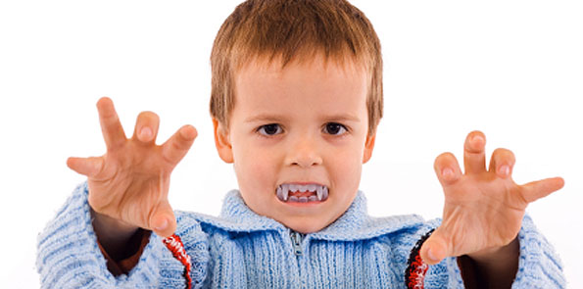
Key issues for staff:
- Biting is neither abnormal nor unusual for children of toddler-room age.
- Now that the issue has been identified, the focus has to be on prevention. Closer supervision is a priority.
- Identification of triggers to aid prevention is vital and an ABC (Antecedent, Behaviour, Consequence) chart can be used to do this.
- How you manage the behaviour at the time of the incident is key. Remove the child who has been bitten and avoid drawing attention to the biter; all attention should be on calming the victim so there is no reward for the biter.
- Avoid the big "say sorry" routine – it is not easily understood by young age groups. Later, when all is calm again, tell the biter calmly that s/he made the other child sad and ask what s/he thinks we could do to make them feel happy again?
- Manage the issue with parents - biting is always emotive BUT best handled by staff showing confidence that the setting is handling the issue and encourage parents to work with you, e.g. "We are helping this child to learn not to bite by ... And we know you would want us to do this for any two-year-old who is struggling to learn how to behave appropriately with others.”

- If proprioceptive concerns are felt to be the root cause, (nursery staff may not have skills required to assess this) crunchy carrot, apple, crisps or chew tubes may help.
- If the child seems to have limited communication skills or is not progressing at a developmentally expected rate, it may be that they are using biting to communicate their needs, frustrations and anxieties. If this is the case, you will need to complete a Speech and Language referral form, including as much information as possible about the child’s behaviour, reactions, triggers and what language the child has.

