Early Years Behaviour Support Plan

Name:
DOB: |  | Age:
Key People |  | Other staff involved in plan:
Date of plan: |  | Date of Review of plan:

Current Behaviour/s causing concern: | Possible Communicative Function:

Traffic light system:
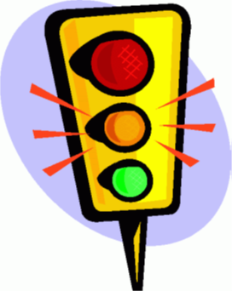 | Green | ‘Typical’ behaviour, e.g. calm, happy, relaxed
 | Amber | Problems may be about to occur; child becomes anxious, distressed, aroused, overwhelmed, silly etc.
 | Red | Problem is occurring; child shouts, is out of control, aggressive, angry
 | Blue | Child calms down; can be sad or exhausted for example

X’s Green Strategy
Behaviour  The things that X does, says, or looks that gives us clues that he is calm and relaxed | Support Strategies  The things that we can do or say to keep X in the green for as much time as possible

X’s Amber Strategy
Behaviour  The things that X does, says, or looks that gives us clues that he is becoming anxious or aroused | Support Strategies  The things that we can do or say to stop the situation from escalating further and return X to the proactive phase as soon as possible

X’s Red Strategy
Behaviour  The things that X does, says, or looks he is using behaviours that challenge us | Support Strategies  The things that we can do or say to quickly manage the situation and prevent unnecessary distress, injury and destruction

X’s Blue Strategy
Behaviour  The things that X does, says, or looks that tells us that he is becoming more calm | Support Strategies  The things that we can do or say to support X to become more calm and return to the proactive phase

