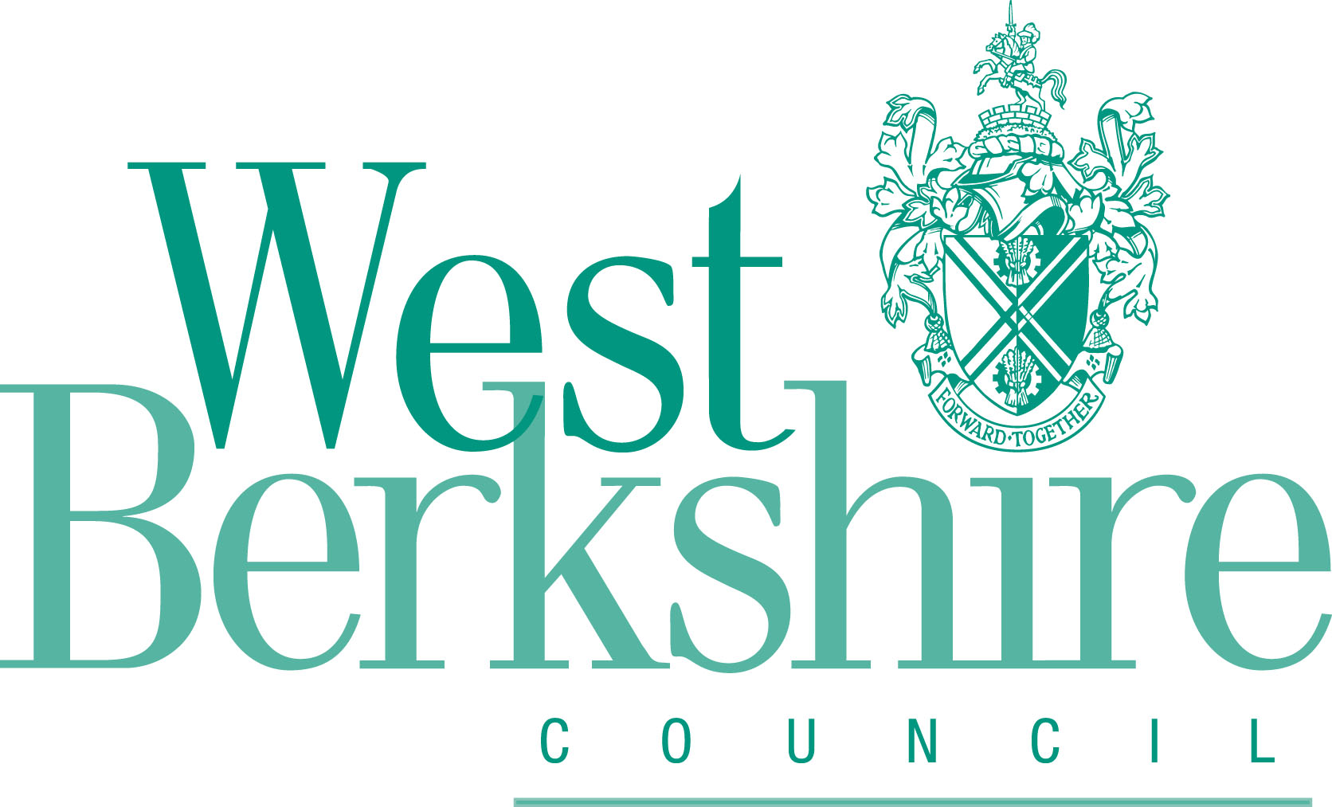
WEST BERKSHIRE DISTRICT COUNCIL
(STATION ROAD, NEWBURY)
(PROHIBITION OF MOTOR VEHICLES) EXPERIMENTAL ORDER 2022

Ref: 008301MS
Closing date for objections: 22nd February 2023

If you wish to comment on the restriction please do so in the space below. This form can be used to indicate your support or objection to the scheme

Please also provide your name and address / email, so that we can respond to your comments in due course.

NAME:
ADDRESS:

E-MAIL:

COMMENT:

Please either email this form back to the team managing this scheme trafficandroadsafety@westberks.gov.uk or post the form to:

Traffic & Road Safety
West Berkshire District Council,
Market Street
Newbury
RG14 5LD

