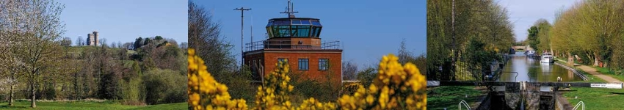

Council Report for April 2026

Written by your local Conservative team to keep you up to date.

Councillor Clive Hooker, Downlands Ward

West Berkshire Council

Council
There was no meeting of Council this month.
The next meeting is the Annual Meeting on 14 May.

Executive
There was no meeting of the Executive this month.
The next meeting is on 21 May.

Community

Safe Places
Safe Places are here to help anyone who is feeling worried, scared, lost, or at risk while out and about. Safe Places are registered venues where anyone can ask for support, whether that’s finding a quiet space, contacting a friend or family member, arranging a taxi, or calling 999 in an emergency.

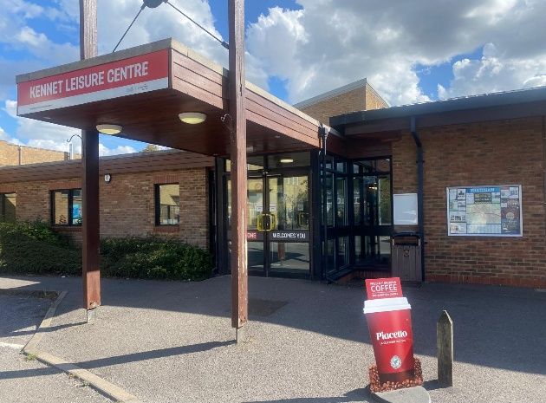
In West Berkshire, Safe Places currently include all libraries, leisure centres and family hubs, and they can be found by looking for the Safe Places sticker or using the free Safe Places app.

New figures show the scheme is being actively used and searched for locally. Since 1 June 2025, the West Berkshire Safe Places membership page has been visited 539 times.

Businesses or community venues who would like to help expand the network, can register as a Safe Place, email safeplaces@westberks.gov.uk or call 01635 551111 and ask for Rhys Lewis.

Environment

Discover the Ridgeway National Trail
A new interpretation board has been unveiled at Streatley Warren as part of the Historic Ridgeway Project. We are partners with the project, which is connecting local communities, landowners, visitors and volunteers to this historic routeway and the ancient landscapes that it passes through in West Berkshire and Oxfordshire.
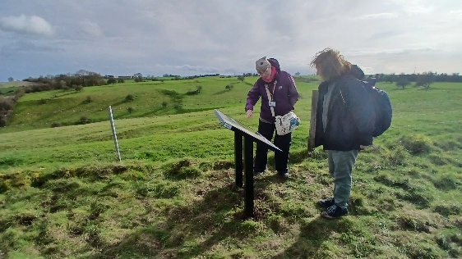
The first board, funded by Mend the Gap, highlights human activity from over two thousand years ago. Streatley Warren was designated a Site of Special Scientific Interest due to its rare chalk grassland habitat, and the lack of modern ploughing has also preserved the earthworks of Iron Age and Roman fields, which show up well in low light in the open landscape. The ancient field systems would have been widely distributed across the Berkshire Downs, and their range is mapped on the board.

Archaeological information from the West Berkshire Historic Environment Record was provided for the board, in collaboration with Historic England, the Friends of the Ridgeway and others. Further boards funded through the North Wessex Downs National Landscape and Farming in Protected Landscapes will be installed in the coming weeks. A QR code on the panels allows visitors to access all of the project’s sites on an interactive map.

Improving the Kennet and Avon Waterside
WBC are working with Walk Wheel Cycle Trust, the Canal and River Trust and Greenham Trust to improve access along the Kennet and Avon Waterside, helping everyone to enjoy the route safely and comfortably.

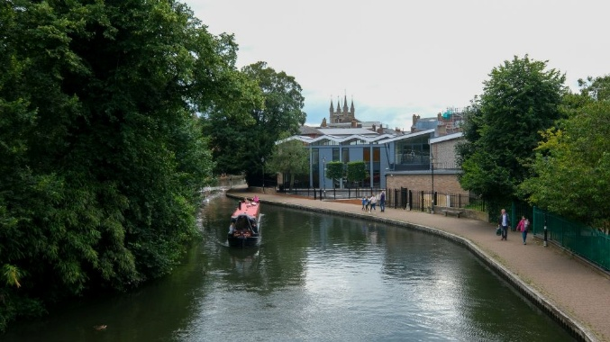
The long-term programme, called Reimagining the Kennet and Avon Waterside, aims to make the route more accessible in stages, so you can enjoy walking, wheeling, cycling or spending time by the water.
The first phase focuses on the ‘Heart of Newbury’, between Faraday Road Football Ground and Goldwell Park.

Planned improvements include path upgrades near Faraday Road Football Ground, towpath and canal bank repairs between Town Bridge and Victoria Park, and new signage and lining on Northcroft Lane linking the town centre with Goldwell Park.

These works build on recent improvements elsewhere, including upgraded sections near Aldermaston, Ufton Lane, Burghfield and Calcot.

The partnership is developing plans for future improvements in Newbury, Thatcham and Calcot, taking account of the natural environment, heritage, flood risk, accessibility and wayfinding.

Transport

A4 Improvements
As part of the Active Travel scheme to upgrade footways and crossings, supported by funding from Active Travel England, WBC have improved and resurfaced all footways from Skillman Drive through to the park next to Kennet School in Thatcham.
On the A4, a central island has been removed and a new crossing with traffic lights that now allows users to cross the road in one go has been installed. The road has been resurfaced with new road markings. The greenery from Archangel Way has been tidied, as well as the A4 to remove overhang from the footway.
Whilst the road was closed for the A4 carriageway resurfacing, further potholes and defects were also repaired.

Health and Wellbeing

Wellbeing Support
Parents, carers and those who work with families in West Berkshire can now access free online emotional wellbeing support through a new NHS platform called Togetherness.

Togetherness offers short, self-guided learning residents can complete at their own pace. It covers topics such as pregnancy and early bonding, children’s feelings and brain development, family relationships, and the changes children and young people experience as they grow. There are also dedicated pathways for teenagers and resources to help professionals support emotional wellbeing in their work.

Developed by NHS experts and backed by psychological research, Togetherness is designed to help better understand emotions, behaviour and relationships, and build confidence, resilience and stronger family connections.

Access here using the code BWFAMILIES.

Culture

Leisure Centres
Leisure centres are seeing more people through their doors following multi-million-pound Council investment to upgrade facilities across the district.


At Cotswold Sports Centre in Tilehurst, the new 3G pitch has proved particularly popular, recording almost 3,000 bookings in its first six months and significantly boosting overall attendance. Hungerford Leisure Centre has also seen encouraging growth, with more people using the gym and taking part in fitness classes since the addition of a new fitness studio.

Kennet Leisure Centre has reported a marked rise in visitors following improvements to the gym and squash courts. Squash in particular has seen a resurgence with participation up 86%, alongside gym visits more than tripling and increased attendance at fitness classes.

Northcroft Leisure Centre has also experienced one of the biggest upturns in activity, with far more people using the gym (up 973%), soft play sessions (up 494%) and children’s parties (up 103%) since the facility upgrades. These positive trends extend to Northcroft Lido, where last season’s attendance increased by 37%, including significant rises in family swims, lane swimming and SEN sessions.

The refurbished Northcroft café has been warmly received too, drawing in both centre users and visitors from the wider community, as visitors don’t need to be leisure centre users to enjoy a great cup of coffee in this lovely space.

Pianos for use
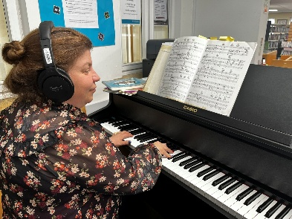
Pianos are available to use in Newbury, Theale and Hungerford libraries, provided by Berkshire Music Trust as part of their Musical Communities programme, giving individuals the opportunity to practise and explore music, particularly those who may not have access to a piano of their own. The Trust has also supplied a selection of sheet music for visitors to use.
Everyone is welcome to play on a first-come, first-served basis. The digital pianos must be used with headphones to ensure other library users are not disturbed

Shaw House
As part of the ongoing project to bring Shaw House’s history to life, WBC are working to reinstate the Edwardian Rose Garden. Complementing the Tudor Garden, which opened at the front of the house in March 2025, the tree work to the rear is helping to recreate the gardens as they appeared in 1910, as originally featured in Country Life magazine.

Over the past few weeks, the historic yew trees have been carefully tamed using wire to restore their elegant, manicured shapes. These are the very same trees that stood here in 1910, and they are now ready to be showcased just as visitors would have seen them over a century ago.

The garden works form just one part of a wider programme of improvements. Inside the house, four rooms have also been dressed to reflect different periods of Shaw House’s long history. These house and garden enhancements have been made possible thanks to funding from the UK Shared Prosperity Fund.
Looking ahead, a brand-new accessible playground, funded by the Community Infrastructure Levy (CIL), is planned to open by summer 2026.

Current Consultations
- Planning Public Access Service feedback survey 2026- 7 May 2026
- Residents' Survey (2026) – 10 May 2026
- Proposed amendment to the Hackney Carriage and Private Hire Licensing Policy 2025-2030 with respect to protected plates and accessibility- 15 May 2026

Cllr Clive Hooker
clive.hooker@westberks.gov.uk
07798 920981

Annual Council Report for Municipal Year 2025-26

Written by your local Conservative team to keep you up to date.

Councillor Clive Hooker Downlands Ward

West Berkshire Council

Local Government Reorganisation

Where we are now?
Local Government Reorganisation is probably the biggest thing going on in Local Government at the moment, affecting many different council areas.

Whilst West Berkshire isn’t in one of the immediate areas for reorganisation, we are interested in a proposal which involves us as part of the Oxfordshire reorganisation.

The consultation has now closed and the responses are being reviewed by HM Government. We are expecting to know their decision by summer, but no firm date has been given and other councils have experienced delays and changes as instability in the Ministry has had effects on work progress.

What is changing?
The move is in response to a government invitation following its announcement in December 2024 to end two-tier authorities like those in Oxfordshire. As part of the shake-up of local councils, the government has also indicated all unitary authorities will need to serve around 500,000 residents or more, which will require West Berkshire Council - which covers around 170,000 people - to merge with neighbouring councils.
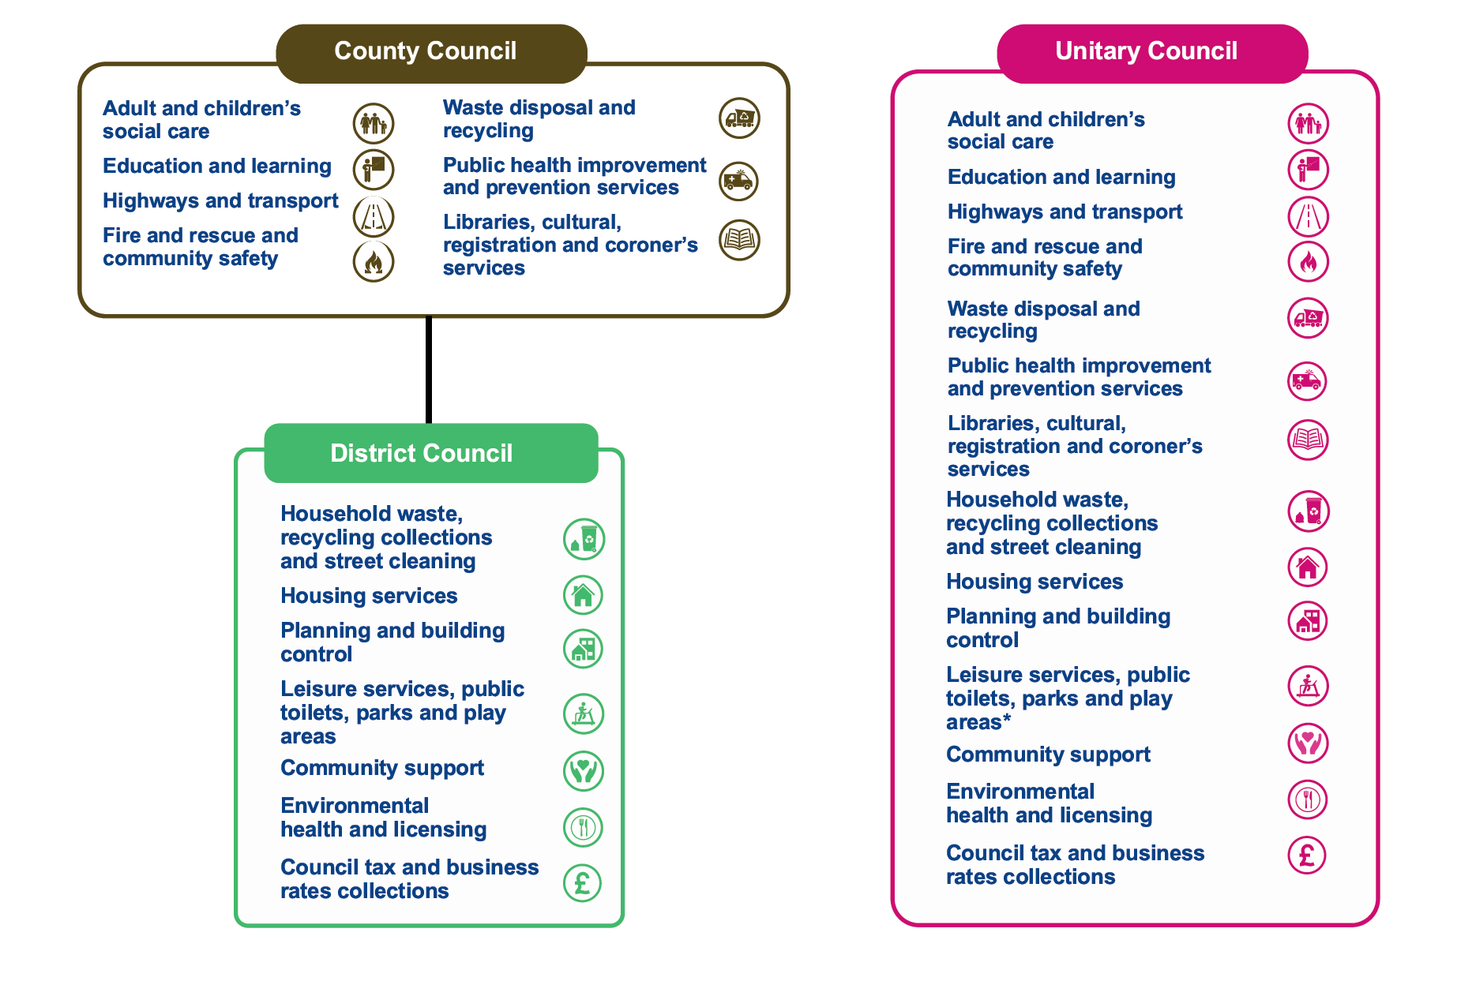

What are the proposals?
The government asked the existing councils to develop proposals for them to consider. There were three proposals submitted to government:
- A single county unitary that covers all of Oxfordshire.
- Two unitary councils that cover Oxfordshire and West Berkshire. One covering the existing council areas of Cherwell, Oxford City and West Oxfordshire. One covering the existing council areas of South Oxfordshire, Vale of White Horse and West Berkshire.
- Three unitary councils that cover Oxfordshire and West Berkshire. One covering the existing Oxford City council area but with expanded boundaries. One covering the remaining existing council areas of Cherwell and West Oxfordshire. One covering the remaining existing council areas of South Oxfordshire, Vale of White Horse and West Berkshire.

Why is this important to businesses in West Berkshire?
Councils have a significant impact on local businesses from strategic work like driving economic growth and housing growth through to provide support to individual businesses and managing town centres. The choice made by the government could impact all of these services for decades to come and so making the right decision for West Berkshire businesses is important.

What do the current councils think is the best option?
Cherwell, South Oxfordshire, Vale of White Horse, West Berkshire and West Oxfordshire overwhelmingly support the two unitary option. 142 out of 158 councillors in attendance at those councils voted to support submitting the two unitary proposal including councillors from all political parties.
Oxfordshire County Council support their single unitary proposal and Oxford City Council support their three unitary proposal.

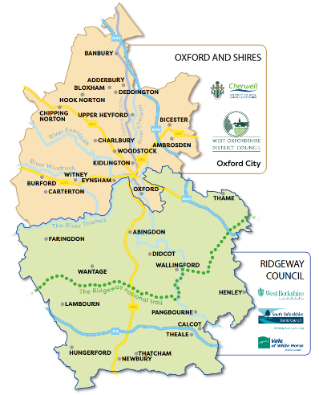
Why does WBC support the two unitary option?
WBC believes that the two unitary proposal is the only one that will deliver improvements to council services, will be financially sustainable, will be responsive to communities and will deliver economic growth.
WBC believe this about creating councils of the right size – not too big that they are distant and ineffective, not too small that they aren’t financially viable. When councillors considered the proposals they felt the two unitary was the one that best met the government criteria and would deliver the best outcomes for West Berkshire businesses.

Want to find out more?
Each proposal has its own website with more information:
- One Council - Oxford County Council
- Two Councils - West Berkshire, Vale of the White Horse, South Oxford, Cherwell District Council, West Oxford District Council.
- Three Councils - Oxford City Council

Financial Troubles
Last year, West Berkshire Council requested Exceptional Financial Support (EFS) to help balance its budget. This was granted, and part of the agreement for the EFS was for the Charted Institute of Public Finance and Accountancy (CIPFA) to investigate the Council’s spending.

The CIPFA report was damning and strongly criticised the Liberal Democrat administration’s financial management. This report’s findings were rejected by the Leader and Executive.

This year, the Council is still in difficulties and, having rejected the findings, needed to ask for another bailout from HM Government.

At the Council meeting on 29 January, the Liberal Democrats proposed a motion to ask the Liberal Democrat Leader to write a letter requesting help, but in doing so continued to ignore the CIPFA findings and blamed HM Government for the mess they are in.

The Conservative group chose not to attend this meeting. Antagonising HM Government when another bailout is needed seems a silly idea, not to mention that the Leader does not need permission from Council to write a letter asking for help – which comes at an additional cost to the taxpayer.

Read more here: https://www.newburytoday.co.uk/news/tories-to-boycott-west-berkshire-council-budget-meeting-9450864/ and https://www.newburytoday.co.uk/news/council-in-cash-meltdown-as-redundancies-are-on-the-agenda-9451022/

Upgrading Schools

Falkland Primary School construction work progressing well
Work at Falkland Primary School is continuing at a good pace, despite some disruption from the weather. Since November, persistent rain has caused around three weeks of delay, but good progress has still been made.
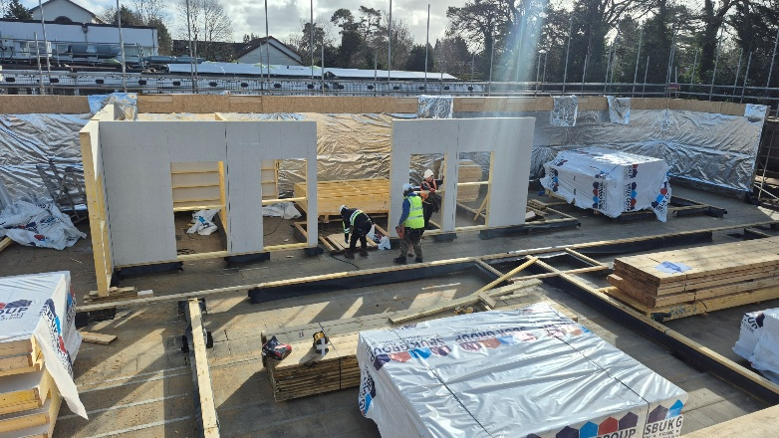
The foundations are now complete, along with the base floor and timber frame. This means the building is really starting to take shape, and you can now walk through it and see how the rooms will be laid out.
Over the next few weeks, steel columns will be put in place, the roof covering will begin, and work will start on the internal floors and staircase.
To help make up for time lost to the rain and keep things on track, there will be some limited weekend working. This will help ensure the building is finished and ready for people to move in before the Autumn Term starts in September.

32 new SEND places at Castle School
The expansion of The Castle School in Newbury is now nearing completion. This is a major milestone in ongoing investment in high quality learning environments for children and young people with Special Educational Needs and Disabilities (SEND).

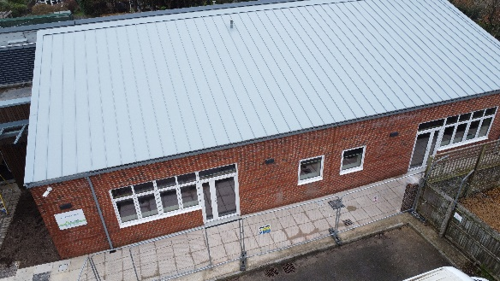
The brand-new Barbury House, named after an Iron Age hillfort in Wiltshire called Barbury Castle, will provide 32 vital SEND places for pupils aged 2 to 19 with complex needs. This expansion not only increases capacity but also enhances the school’s specialist offer, with thoughtfully designed breakout spaces and group rooms to better support tailored learning, wellbeing, and care.

By creating more SEND places locally, the new building will also deliver significant financial benefits. Each placement at Barbury House is estimated to save around £80,000 per year compared to an out of district alternative, ensuring that more West Berkshire children can receive the support they need close to home.

Delivering for the Environment

Bee Bus Shelters
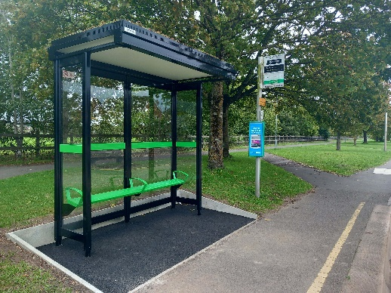
Bus Passengers across West Berkshire are beginning to benefit from new bus shelters being installed, helping to improve the Public Transport experience. WBC have provided funding to town and parish councils who are responsible for maintaining shelters.

Many of the shelters have green roofs helping to contribute towards efforts to tackle the climate and ecological emergency. It follows feedback from bus surveys, where residents said the condition of bus stops influences how they travel.

These improvements are made possible by funding from HM Government, given to the Council after submission of the Bus Service Improvement Plan (BSIP).

Electrical reuse scheme launches at recycling centres
WBC have teamed up, in partnership with Veolia, with Green Machine Computers to launch an exciting new electrical reuse scheme at both Household Waste Recycling Centres in Newtown Road and Padworth.

Residents can now drop off used mobile phones, tablets, laptops and desktop computers at dedicated collection points at either site, giving their old devices a new lease of life.

Once collected, Green Machine Computers will securely remove any data before passing reusable items to The Tech Hub in Hungerford. From there, they will be made available free of charge or at low cost to charities and people in need, ensuring technology reaches those who need it most.

Changes to Bin Collections
The Liberal Democrats made a change to black bin collections in West Berkshire. From last year, black bins are now collected every three weeks instead of every fortnight.

It's important to note that these changes will not affect:
- Households with communal bin stores (e.g. flats)
- Weekly food waste collections; and
- Fortnightly recycling and garden waste collections

At the end of last year, there was a consultation in which most people voted against the change to reduce black bin collections to once every three weeks instead of every fortnight. Despite clear opposition, the administration decided to press ahead with the changes.

Residents who have a large family and/or have someone in the home who has a medical condition that generates a significant volume of unrecyclable waste, can apply for extra rubbish capacity here.

U Turn on Resource Centres
The Liberal Democrats announced that they are uturning and now plan to continue to run the Resource Centres directly, following pressure from residents and opposition councillors.
To ensure long-term sustainability, they will be co-locating complementary services within the same buildings - keeping services affordable, connected, and close to home.
It is hoped this decision will ensure residents receive high-quality, accessible, and cost-effective support.

Continuing Successful Projects
The previous Conservative Administration of WBC (Pre 2023) started a number of schemes and projects which we are proud are continuing with success and providing benefits to local residents and their communities.

Bikeability
WBC are continuing to run Bikeability training courses during school holidays for children and sometimes adults too.
All courses are run by DBS checked, fully-qualified Bikeability instructors and currently cost £25 per course. The child’s bike must be fully road-worthy and the right size. The instructors have the right to refuse training if the bike is deemed unsafe.
More information and how to book is available here.

Soil Conditioner
WBC have now held eight soil conditioner give-aways on where residents could collect free, peat-free, PAS 100 certified soil conditioner produced locally from West Berkshire's garden waste.

No appointment is required to attend these give-away events, just proof of address, such as an ID card or recent utility bill, to confirm they live in West Berkshire.

The soil conditioner is provided loose, for residents to fill into their own bags, boxes or containers.

This is always a popular event so with many queues during busy periods and short delays while containers are refilled.

Home composting is a simple, cost-effective way to turn garden and kitchen waste into nutrient-rich compost for plants. By composting at home, residents reduce the amount of waste sent for disposal and create a natural soil improver that helps gardens thrive. Most garden waste, fruit and vegetable peelings, tea bags, coffee grounds, and even shredded paper can go into a compost bin. Avoid cooked food, meat, and dairy, as these can attract pests.
With the right mix of "greens" (like grass cuttings and food scraps) and "browns" (like twigs and cardboard), healthy compost will be ready in a few months.
1. Reduce waste and save money
composting diverts food and garden waste from your black bin saving vital space for non-recyclable items it's a free alternative to paid garden waste services, turning your waste into a valuable resource
2. Create free fertiliser
compost is rich in nutrients and improves soil structure, moisture retention, and plant health use it in your garden beds, pots, or as mulch - no need to buy chemical fertilisers
3. Help the environment
it supports biodiversity by improving soil health and feeding beneficial organisms
4. Easy to start
you can compost using a bin, a pile, or even trench composting directly in your garden West Berkshire residents can buy compost bins from the Get Composting website
Recycle Now provide great tips and useful advice to get your compost bin started.

Holiday Activities and Food Programme
The Holidays Activities and Food (HAF) programme offers free holiday club places for children and young people eligible for free school meals.
The activity sessions are run during school holidays at no cost to parents, and include:
- Sports, music, arts and crafts
- Outdoor and indoor play, gaming and other exciting opportunities to learn and develop skills
- A nutritious meal each day
- Nutritional resources to keep
- Fun workshops and visits at selected venues
To find out if a child is eligible, please contact their school or WBC’s HAF Coordinator.

Free Bus Schemes
A double decker bus at full capacity can take over 2km of cars off the road, and the free bus travel has helped promote local businesses and encourage more sustainable transport. By helping more people to access buses and encourage people out of their cars, the amount of congestion on our roads has reduces and the air quality improves.

These happen regularly now, particularly around holidays when more people are looking to get out and about, as well as on days such as World Car Free Day, where a wider campaign is involved.

Streatley Footpath 21 officially open
After 20 years of anticipation, WBC are delighted to share that Streatley Footpath 21 is now open for everyone to enjoy!
Originally established in 2004 as part of planning permission for The Swan Hotel, the footpath remained unusable for many years due to challenging terrain, including drainage ditches, dense vegetation, and persistently wet ground.
Over the past five years, Countryside and Public Rights of Way Teams have led a series of improvements guided by ecological recommendations. These included safety tree work supported by bat surveys, vegetation clearance, water level studies, and the installation of two bridges.
A big thank you to all those involved in making this happen including: Mid and West Berkshire Local Access Forum, Mend the Gap, The Swan Hotel, the Berkshire Ornithological Club, the Mobility Issues Group for Goring and Streatley (MIGGS), and neighbouring landowners.

Cllr Clive Hooker
Clive.hooker@westberks.gov.uk
07798 920981

