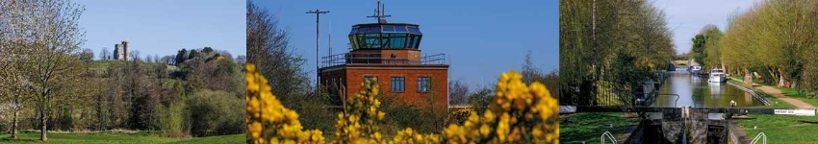

# Council Report for September 2024

### Written by your local Conservative team to keep you up to date.

### Cllr [NAME], [NAME] Ward

## West Berkshire Council

#### Council

An Extraordinary Council was held on 5September following a request from the Conservative Group to review the decision to clawback West Berkshire schools’ surplus funds to be applied to their budgets for the financial year 2024-25.

Council also met on 26 September to discuss:

* Hampshire Together Joint Health Overview and Scrutiny Committee
* Recommendations of the West Berkshire Independent Remuneration Panel 2024

Papers and recordings of the meetings can be found [here](https://decisionmaking.westberks.gov.uk/ieListMeetings.aspx?CId=116&Year=0).

The next meeting is on 28 November.

#### Executive

Executive met on 19 September to discuss:

* Financial Year 2024/25 Quarter One Capital Financing Performance Report (EX4513)
* 2024/25 Revenue Financial Performance Quarter One (EX4516)
* Draft Waste Management Strategy (EX4406)
* West Berkshire Domestic Abuse Strategy 2024-27 (EX4546)
* Carers Strategy (EX4577)
* Customer Charter Refresh (EX4534)
* Charitable Sector Memorandum of Understanding (EX4597)
* 2024/25 Performance Report Quarter One (EX4540)
* Accommodation Review: Proposed Disposal of Unit 1 Turnhams Green Business Park (EX4507)

Papers and a recording of the meeting can be found [here](https://decisionmaking.westberks.gov.uk/ieListMeetings.aspx?CId=117&Year=0).

The next meeting is on 7 November.

#### Planning

The below sites have been submitted through the Local Plan process as available for delivery of the new homes. These sites will deliver the additional homes the Planning Inspector has asked to be included in the Local Plan Review to be able to conclude that the plan is sound.

###### Thatcham

Approximately 225 homes are proposed for land near to Henwick Park, on Bowling Green Road in Thatcham. This includes space allocated within the site for a landscape buffer. [Map](https://content.govdelivery.com/attachments/UKWESTBC/2024/08/16/file_attachments/2969352/Henwick%20Park,%20Thatcham.jpg).

Approximately 45 homes are planned for land east of the Regency Park Hotel on Bowling Green Road in Thatcham. This includes space allocated within the site for a landscape buffer. [Map](https://content.govdelivery.com/attachments/UKWESTBC/2024/08/16/file_attachments/2969371/Land%20East%20of%20the%20Regency%20Park%20Hotel,%20Thatcham.jpg).

The Planning Inspector has also found that the site proposed at North East Thatcham has capacity beyond the 1,500 homes proposed and has found that to make effective use of the site this should be expanded up to 2,500 homes. Not all of these additional 1,000 homes would be built within this plan period, with the majority likely to be delivered after 2041. The final capacity of the site will be determined through the creation of a masterplan which will be developed collaboratively by the Council and developer and with comprehensive engagement with the local community.

###### Calcot

Approximately 138 homes are planned on land at Pincents Lane in Calcot. This includes space allocated within the site for a community parkland and public open space. [Map](https://content.govdelivery.com/attachments/UKWESTBC/2024/08/16/file_attachments/2969372/Pincents%20Lane,%20Calcot.jpg).

###### Pangbourne

Approximately 25 homes are planned for land north of Pangbourne Hill in Pangbourne. This includes space allocated within the site for a landscape buffer. [Map](https://content.govdelivery.com/attachments/UKWESTBC/2024/08/16/file_attachments/2969374/Pangbourne%20Hill,%20Pangbourne.jpg).

###### Newbury

West Berkshire Council has also identified an area north of Newbury which could be explored for future growth as it has the potential to deliver between 650 and 800 homes, later in the plan period (from 2034 onwards).

#### Education

##### Francis Bailey Safer Streets Scheme

Following a six-month public consultation, the School Streets scheme will now be made permanent at Francis Baily Primary School in Thatcham.

Inspired by the successful Calcot School Street project, the scheme aims to create safer and less congested roads around the school during peak hours.

An Automatic Number Plate Recognition (ANPR) camera will now be installed to enforce traffic restrictions so that parents and children can feel safer walking or cycling to school.

WBC are working with the school to promote the Bikeability cycle training and encourage pupils to make full use of bike and scooter storage provided as part of the School Streets scheme.

Two new Park & Stride locations have also been identified, one at Old Bluecoats School and the other at Dunstan Green Park. These are just a five minute walk from the school, so that parents can park easily and walk their children the rest of the way.

##### Works progress at new facility for Kennet Valley Primary School

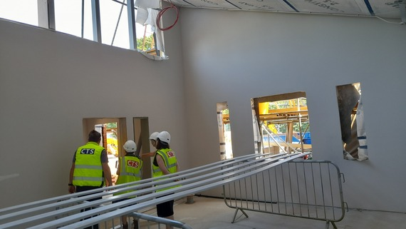Work is well underway on a fantastic project at the Kennet Valley Primary School site in Calcot to create a special facility for primary school children with Social, Emotional and Mental Health (SEMH) needs.

Children attending the SEMH unit will benefit from having their needs met by a local and specialised setting, but will also be valued and cared for as part of Kennet Valley’s existing school culture; taking part in school events and sharing school facilities where appropriate.

Almost £3 million has been invested in the purpose built space which will eventually provide places for twelve children, starting with the first six this coming September and the facility will comprise of two classrooms for six pupils, four small group rooms, a therapy room, an outdoor space for teaching and breaks, a teaching kitchen, social area for pupils, plus a large meeting room and a staffroom and offices.

#### Culture

##### Book Clubs

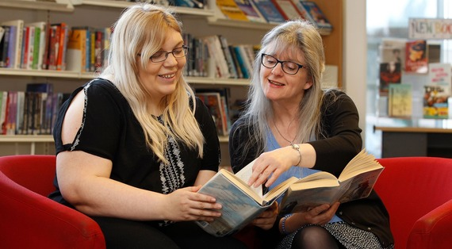Book groups are a great way to meet with friends and share thoughts about books in a friendly atmosphere (often along with food and drink!). Residents who belong to a book group can borrow sets of books for the group from their local library. WBC can supply sets of 10 copies of the chosen title and have over two hundred sets to choose from. Please email [library@westberks.gov.uk](mailto:library@westberks.gov.uk) for details.

Residents can also start their own book group, WBC can help with that too. Alternatively, some libraries run their own book groups, which new members are welcome to join.

#### Environment

##### Kerbo Charge

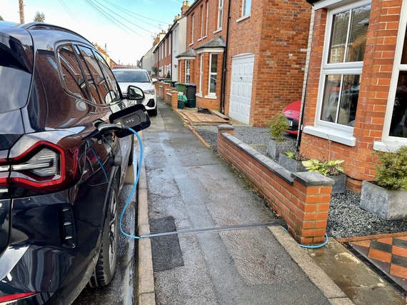West Berkshire Council is leading the way as one of the first UK councils to offer a through-pavement system for charging electric vehicles (EV) on the street.

After a successful trial over the last 9 months, the innovative Kerbo Charge system is now being rolled out across the district. Residents can now charge their EVs from their home supply, which is 5 to 10 times cheaper than public chargers. This initiative will help improve air quality and reduce CO2 emissions in West Berkshire.

Here's how it works: when a resident wants to charge their car, residents simply insert their charging cable into the channel, and the specially designed lid closes behind it like a zip, eliminating unsightly and hazardous cables stretching across footpaths.

##### Garden Waste

The Garden Waste collection for the new subscription year started from 26 August 2024, with collections on the normal day, even if it’s a bank holiday.

For the 2024/25 garden waste collection service, WBC won't be issuing bin stickers. Instead, collection crews will use in-cab technology to verify which properties have subscribed, making stickers unnecessary. To help identify bins, residents might want to mark it with the house number or name using permanent marker or paint.

WBC are enhancing monitoring to ensure only subscribed bins are collected. This includes checks by crews, spot inspections by council officers, and the removal of green bins if put out from non-subscribers.

#### Waste

Residents are invited to have their say on the WBC Draft Waste Management Strategy, which outlines a vision for a greener future, including:

* Moving to three weekly bin collections.
* A review of the containers used by households.
* Increasing recycling rates to at least 60% by 2030.
* Cutting residual waste to 120kg per person per year by 2042.

Residents should complete the survey by midnight on 6 November 2024.

Paper copies of the survey are available on request. Please ring: 01635 519 080 or email: recycle@westberks.gov.uk to request a copy.

Copies are also available at the Council Office Reception, Market Street Newbury, RG14 5LD during opening times Mondays - Thursdays 8:30am – 5:00pm and Fridays 8:30am - 4:30pm.

In addition, WBC are offering drop-in sessions at local libraries where you can talk to a member of the team on the draft Waste Strategy – times and locations can be found [here](https://www.westberks.gov.uk/draft-waste-management-strategy).

#### Economy

##### Proposed Pedestrianisation Trial in Newbury

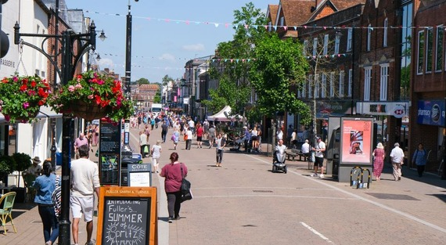Residents, businesses, visitors and road users are invited to share their views on a proposed trial to extend pedestrianised hours in Newbury Town Centre.

Currently, Newbury’s town centre streets - Northbrook Street, Bridge Street, Bartholomew Street (North), Mansion House Street, Wharf Street, and Market Place - are pedestrianised with no vehicle access from 10:00am to 5:00pm. The proposed trial, which is part of the Council Strategy 2023-2027, would extend this period of no vehicle access from 10:00am to 11:00pm.

This pre-trial consultation is a simple yes/no exercise to gauge public opinion before any decisions are made. If support is shown, an Experimental Traffic Regulation Order could be introduced to trial the changes in spring 2025. This follows a previous attempt to pedestrianise Newbury last year.

Residents should share their views in the [survey](https://www.westberks.gov.uk/pedestrianisation-pre-trial) by midnight on Tuesday 5 November.

#### Transport

##### Free Bus Travel

Buses are an environmentally friendly way to get out and about. To show support for World Car Free Day this year, WBC have again partnered with local bus operators to offer free bus travel across the district for the day.(Reading Buses JetBlack, 15, 16, 26 and 33, Stagecoach 32, Thames Travel X34)

In addition to the usual Sunday bus services, WBC also have a Special one-off service on the X34 between Newbury and Didcot. (Newbury Show Buses are not included in this event)

Free Bus Travel is also being planned on Saturday 16 November, Saturday 14 December and Saturday 21 December in the run up to Christmas.

Why not leave the car at home, and visit friends and family by bus, or a day out in Basingstoke, Didcot or Reading.

This free bus travel offer has been made possible by funding from HM Government, given to West Berkshire Council after the successful submission of a Bus Service Improvement Plan (BSIP) in October 2021.

#### Current Consultations

* [Argyle Road, Hampton Road and Derby Road, Newbury: Proposed 20mph speed limit by Traffic Regulation Order](https://www.westberks.gov.uk/20mph-TRO9529) – Closes 3 October 2024
* [Pedestrianisation of Newbury](https://www.westberks.gov.uk/pedestrianisation-pre-trial) – Closes 5 November

# Parish Matters

#### Topic

##### Heading

Text