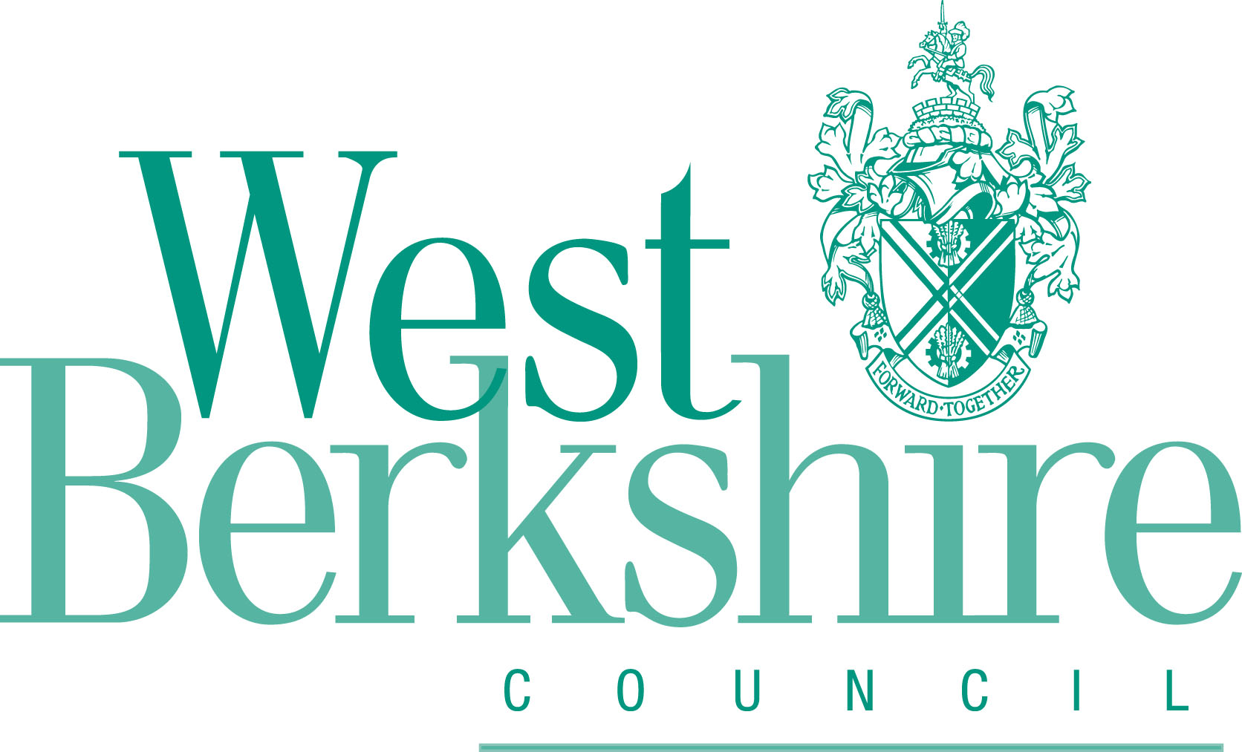
West Berkshire District Council (VARIOUS ROADS, YATTENDON)
(30 MPH AND 40 MPH SPEED LIMIT) ORDER 201[ ]

Ref: 006308MS
Closing date for objections: 27 December 2018

If you wish to object to the proposals, please do so in the space below stating your grounds for objection. This form can also be used to indicate your support or for providing comments.

Please provide your name and address / email, so that we can respond to your objection in due course.

NAME:
ADDRESS:

E-MAIL:

Please either email this form back to the officer managing this scheme cvidler@westberks.gov.uk or post the form to:

Chris Vidler
Senior Engineer
Traffic & Road Safety
West Berkshire District Council,
Market Street
Newbury
RG14 5LD

