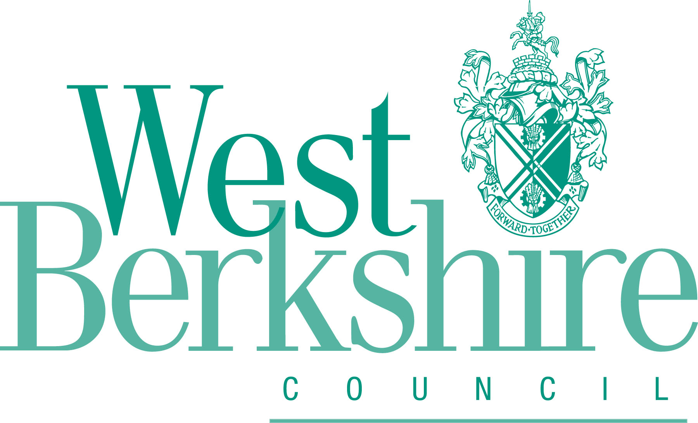 | West Berkshire Council  Self and Custom Build Registration Form for Individuals

Please return this form: | Online: www.westberks.gov.uk/selfbuild
 | By email: planningpolicy@westberks.gov.uk
 | By post: Planning Policy, Planning and Countryside, Council Offices, Market Street, Newbury, RG14 5LD

Self and Custom Build Registration Form for Individuals

Contact Details
Name*:
Address (please include postcode)*:
Email address:
Telephone number:
Date of Birth*:
*Mandatory Field

Please confirm the following statements: | Yes
You are a British Citizen, National of an EEA State other than the UK or a national of Switzerland*?
You are over 18 years of age*?
You are seeking to acquire a serviced plot of land in West Berkshire District to build a house to be occupied as their sole or main residents*?
*Mandatory Field

Requirements
What type of properties would you like to build?
Detached House |  | Detached Bungalow |  | Apartment/Flat
Semi-Detached House |  | Semi-detached Bungalow |  | Other
Terraced House |  |  |  | If other please specify:

How many bedrooms do you require?
1 Bed |  | 3 bed |  | 5+ bed
2 bed |  | 4 bed

In which area are you interested in living?
Newbury & Thatcham |  |  | AONB |  | East Kennet Valley
Newbury |  |  | Hungerford |  | Burghfield Common
Thatcham |  |  | Lambourn |  | Mortimer
Cold Ash |  |  | Pangbourne |  | Aldermaston
Eastern Area |  |  | Chieveley |  | Woolhampton
Calcot |  |  | Compton |  | Other:  (Please Specify)
Tilehurst |  |  | Great Shefford
Purley-on-Thames |  |  | Hermitage
Theale |  |  | Kintbury

What is your connection to West Berkshire? | Tick
I live in West Berkshire
I work in West Berkshire
I have family connection to West Berkshire
If none of the above please give details:

When would you hope to start building?
Under a year: |  | Two to four years:
One to two years: |  | Over four years:

Signature |  | Date:

