Flood Action Plan

To improve operational effectiveness during flood events for the River Kennet and Kennet & Avon Canal through Newbury

Flood Action Group

March 2013

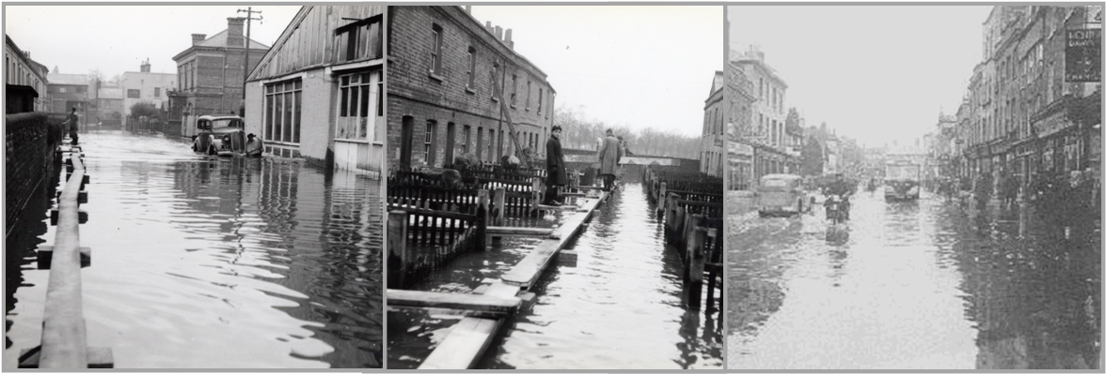

Flood Action Plan

Contents

Purpose of the Flood Action Plan 1

Coverage of the Flood Action Plan 2

Delivery of the Flood Action Plan 3

Components of the Flood Action Plan 4

Framework for action – initiation 5

Framework for action – improve co-ordination 5

Framework for action – staffing / training 6

Framework for action – structural measures 6

Framework for action – other initiatives 7

Commitment to the Flood Action Plan 8

# Purpose of the Flood Action Plan

The Flood Action Plan (FAP) for the River Kennet and Kennet & Avon Canal through Newbury sets out a framework of actions to formalise the current informal and occasionally ad-hoc operational arrangements in place during flood events for the many and variously owned flow and level control structures through Newbury.

The FAP aims to address the concern that consistently effective operation of all structures is not being achieved and that the current informal and occasionally ad-hoc operational arrangements are not acceptable during flood events.

One proposed output from the FAP includes a technical report of all the river control structures and flood defences on the River Kennet, Kennet & Avon Canal and associated tributaries through Newbury. Additionally the FAP could look to highlight other weaknesses in water management and flood risk management and provide a framework/forum to address these.

The operational procedures for the manually operated structures need to include clear lines of communication and procedures that govern the sequencing of opening the control structures through Newbury. They also need to reflect the operating protocols for the system as a whole, not just in response to local increases in flows, i.e. the trigger will be a flood warning, then information of conditions upstream communicated by other operators, etc.

Monitoring and record keeping is required so that performance can be assessed, to provide invaluable information for technical and modelling (calibration) studies and ultimately to decide if operational procedures need updating. The operators should be responsible for this.

**Proposed way forward**:

* Set up a Flood Action Group for delivery of the FAP.
* All parties sign up to a memorandum of understanding.
* Schedule meetings and follow through on the many actions set out in the FAP.
* Formalise the operational arrangements – clarify responsibilities and improve coordination.
* Review the short term and longer term measures, including maintenance.
* Longer term (over 10 years) – promote river improvements and initiate funding.

**A key role of the Flood Action Group will involve acting together to lobby for improvements.**

# Coverage of the Flood Action Plan

The FAP focuses on the capacity and operation of the river/canal system and associated key flow control structures in the environs of Newbury – see figure below with coverage indicated by the arrow (source: Environment Agency website flood map). This includes those structures upstream and downstream whose operations have a direct hydraulic impact on, or are impacted by, the operation of the Newbury system.

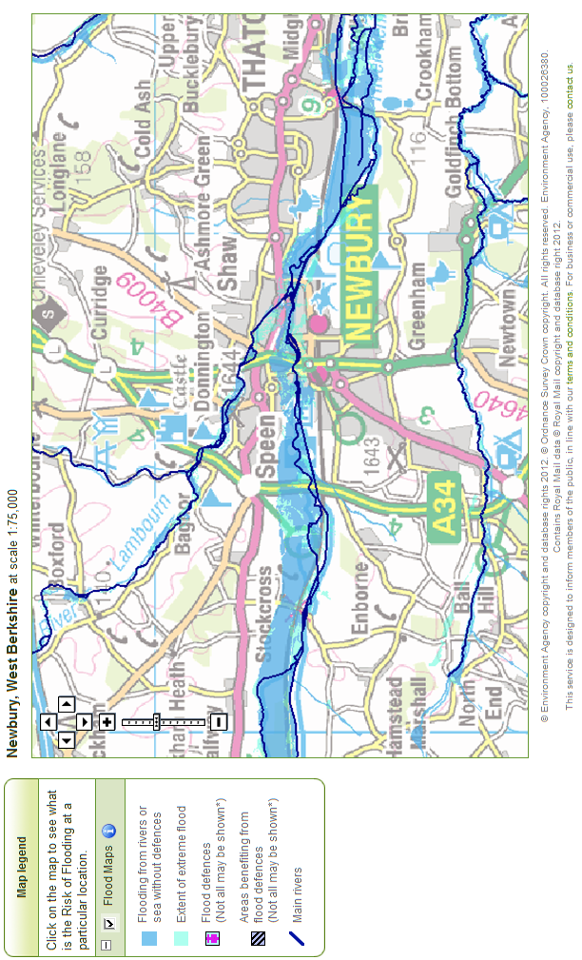

# Delivery of the Flood Action Plan

A Flood Action Group will oversee delivery of the FAP. West Berkshire Council will take the role of overall lead as Flood Coordinator, convening regular meetings, initially monthly and later on a quarterly basis once the coordination and operational roles are well established.

The Canal & River Trust will play a vital role on the basis that they own or operate the majority of the structures that control flows through Newbury. The Canal & River Trust has a Water Controller on duty 24/7/365 with the ability to call out of hours team for assistance.

The Environment Agency have operational and maintenance responsibility only for Bone Mill sluices and fish passes (Ham Mill and Northcroft), which limits their role in controlling flood flows through Newbury. They also perform an important role in many other aspects of flood risk management that directly benefit Newbury.

A priority will be to review operational arrangements for operating flow control structures at times of flooding and to make provision for back-up plans in case of operational difficulties during high flow events. These back-up plans may already be in place, in which case it is important that other operators are fully aware of them.

Additionally, there needs to be more work undertaken to co-ordinate and document the optimal operation of the structures to maintain the pound water levels. Initially this could be based on the knowledge of the operators or level boards could be installed to make the operation easier, backed up by technical study to review all the river control structures and flood defences.

**Flood Co-ordinator**

* West Berkshire Council

**Flood Action Group**

* Private owners & operators
* Canal & River Trust
* Environment Agency

**Key players**

Flood Co-ordinator

* Stuart Clark, Principal Engineer,   
  West Berkshire Council

Canal & River Trust

* Mark Stephens, Waterway Manager
* John Kearsey, Senior Water Engineer

Environment Agency

* Andy Theaker, assets team
* Brian Roberts, Strategic Partnership

Private owners & operators

* list to be compiled full

`

**Supporting organisations**

* Newbury Town Council
* WBC emergency planners
* Emergency services
* Environment Agency   
  (flood warning, etc.)
* Kennet & Avon Canal Trust

# Components of the Flood Action Plan

|  |  |
| --- | --- |
| **A. Clarify operational responsibilities** | **Lead** & Partners |
| * Establish Flood Action Group to take forward the action plan * Flood Action Group to assign a Flood Co-ordinator and deputy * Register of operational responsibilities * Clarify operational responsibility at Ham Mill | **West Berkshire Council**  Canal & River Trust  Private owners & operators  Environment Agency |
| **B. Improve operational co-ordination** | **Lead** & Partners |
| * Protocols for accessing flood warning * Protocols for disseminating operational activities * Protocols for back-up operator in absence of main operator * Register of operational (and maintenance) responsibilities * Operational rules for downstream control * Operational rules to create in-system/floodplain storage * Monitoring and record keeping (to justify further interventions) | **West Berkshire Council**  Canal & River Trust  Private owners & operators  Environment Agency |
| **C. Staffing / training** | **Lead** & Partners |
| * Increased staffing * Training of all operators and to raise awareness of the other flow control structures and how operations can affect the flood regime through Newbury | **West Berkshire Council**  Canal & River Trust  Private owners & operators  Environment Agency |
| **D. Modifications to Victoria Park sluices** | **Lead** & Partners |
| * Replacement of gates | Canal & River Trust  Kennet & Avon Canal Trust (fundraising) |
| **E. Rehabilitate Ham Mill weir and sluices** | **Lead** & Partners |
| * Rehabilitate central Ham Mill weir gate (automated Nov 2012) * Rehabilitate outer Ham Mill weir gates * Rehabilitate Mill Race gate; lower stop-logs | **Private owners & operators**  Mr and Mrs J Fidler  Canal & River Trust  Kennet & Avon Canal Trust (fundraising)  Environment Agency |
| **F. Improvements at Ham Mill** | **Lead** & Partners |
| * New gates for mill race intake | **Private owners & operators**  Canal & River Trust  Kennet & Avon Canal Trust (fundraising) |
| **G. Asset inspection to include vulnerable river/canal banks** | **Lead** & Partners |
| * Asset inspection for river/canal banks near Ham Mill * Asset inspection for other bank locations | **Private owners & operators**  **Canal & River Trust**  Environment Agency |
| **H. Review potential for increased telemetry and automation** | **Lead** & Partners |
| * Flow control improvements as a longer term initiative | **Canal & River Trust**  Private owners & operators  Environment Agency |
| **I. Review emergency procedures for extreme flooding** | **Lead** & Partners |
| * Review emergency procedures – save lives, minimise damages | **West Berkshire Council**  Canal & River Trust  Private owners & operators  Environment Agency  WBC emergency planning |

# Framework for action – initiation

|  |  |  |
| --- | --- | --- |
| **Component** |  | **Next steps** |
| * 1. Establish Flood Action Group to take forward the action plan | * Invite key players to inaugural meeting. * Issue this FAP report in advance of meeting. * Hold start-up meeting chaired by WBC. * Review this FAP and decide priorities. * Reach agreement to FAP delivery. * Sign-up to the charter or similar (presented later). * Agree schedule of further meetings. | Send out invitation letters for start-up meeting, giving at least 4 weeks notice.  Send out this FAP report (when finalised) at least 2 weeks before meeting.  Within 3 months hold meeting and deliver the following:   * key players contact list * decide lead roles * terms of reference * registers * agreement for Ham Mill * memorandum of understanding or similar |
| * 1. Flood Action Group to assign main roles for delivery of FAP | * Agree main roles of Flood Action Group . * Review any training requirements. |
| * 1. Register of operational responsibilities | * Develop the initial register (presented later). * Prepare similar register to cover other responsibilities of riparian owners, e.g. river banks. * Land registry search to ascertain all owners and compile database of relevant information, e.g. as-built drawings. |
| * 1. Clarify operational responsibility at Ham Mill | * Review the issues  (more detail given in background). * Prepare operating agreement with back-up plan |

# Framework for action – improve co-ordination

|  |  |  |
| --- | --- | --- |
| **Component** |  | **Next steps** |
| * 1. Protocols for accessing flood warning | * Consult with the Environment Agency on their flood warning service. * Develop protocols in case of flood warning including responsibilities and clear lines of communication for disseminating operational activities, including back-up operator for each structure. * Formalise arrangements by drafting operational rules (discussed later) | Flood Action Group to assign responsibilities to improve operational co-ordination.  Within 6 months formalise the current informal and ad-hoc operational arrangements.  Install gauge boards to aid operational control. |
| * 1. Protocols for disseminating operational activities |
| * 1. Protocols for back-up operator in absence of main operator |
| * 1. Register of operational (and maintenance) responsibilities* | * Complete the initial register (shown later). * Develop similar for maintenance responsibilities for flow control structures, river/canal banks, etc. |
| * 1. Operational rules for downstream control | * Consider rules for downstream by improving coordination between operators to help pass the flood wave (unimpeded) through the pounds. |
| * 1. Operational rules to create in-system/ floodplain storage | * Consider rules to hold flood water in the floodplain upstream of Northcroft sluices and further upstream of Newbury – helps to attenuate the flood wave and gives downstream operators more time. (*check law on impounding flood water) * Limited (if any) opportunity for any flood storage benefits in the middle and lower pound through Newbury. |
| * 1. Monitoring / record keeping in high flow events (to justify further interventions) | * Basic log to record structure operations during high flow events – date/time, gate operated, gate opening, etc. As done for Thames weirs. |

# Framework for action – staffing / training

|  |  |  |
| --- | --- | --- |
| **Component** |  | **Next steps** |
| * 1. Potential for increased staffing | * Review level of staffing, e.g. may be inadequate as only one operative of Canal & River Trust responsible for operating many structures in Newbury and the Environment Agency team includes 2 flood defence engineers and 5 operational staff for Kennet catchment (Avebury to Reading). * Improve the liaison and co-ordination with several other private owner operators – requires a step change by formalising the current informal procedures. | Canal & River Trust to report to the Flood Action Group with review of staffing.  Decide if current staffing is adequate for such a physically large and complex system that is primarily manually operated.  Within 6 months capture the knowledge from a previous experienced operator. |
| * 1. Training of Canal & River Trust and private operator staff | * Knowledge transfer and training from a previous experienced operator – envisage that the Flood Coordinator and deputy are involved in this. * Document this knowledge and review options for succession planning – who takes over in case of staffing changes. |

# Framework for action – structural measures

|  |  |  |
| --- | --- | --- |
| **Component** |  | **Next steps** |
| **Modifications to Victoria Park sluices** | | |
| * 1. Replacement of gates | * Old structure rated as very poor to fair condition from previous inspection (Halcrow, 2010); suffers debris blockage problems. * Monitor condition as structure and start planning for lifecycle replacement. * Investigate increasing flow capacity (in conjunction with Ham Mill) – this will improve operation and could provide limited mitigation for climate change, subject to no adverse impact on SSSI downstream. * Note: community led hydropower scheme is a possibility at Victoria Sluices (advised in 2011). | Canal & River Trust as owners of this structure to lead on this.  Within 12 months complete a review and draw up plans for the medium term. |
| **Rehabilitate Ham Mill weir and sluices** | | |
| * 1. Rehabilitate central Ham Mill weir gate | * Works in progress to reinstate automated control. | Private owners & operators of the structures to lead on this.  Within 6 months complete review and draw up plans for the short to medium term. |
| * 1. Rehabilitate outer Ham Mill weir gates | * Rehabilitate the operating mechanism and gates in poor condition and dogging mechanism not working – considered dangerous to operate. * Note: recent failure of gate ‘weld’ requires repair (completed November 2012). |
| * 1. Rehabilitate Mill Race gate; lower stop-logs | * Rehabilitate the operating mechanism – broken worm drive with down gearing. * Option to lower the timber stop-logs to increase flows into river downstream – only marginal benefit. |
| **Improvements at Ham Mill** | | |
| * 1. New gates for Mill Race intake | * Potential to reinstate gates that stanked-off with timber stop logs. * Condition of mill race requires internal inspection before any such change in flow regime. | Private owners & operators of the structures to take the lead on this. |
| **Longer term** | | |
| * 1. Replacement of gates | * Investigate increasing flow capacity at Ham Mill as part of lifecycle replacements – this will improve operation and could provide limited mitigation for climate change. | Private owners & operators of the structures to lead on this. |

# Framework for action – other initiatives

|  |  |  |  |
| --- | --- | --- | --- |
| **Component** | |  | **Next steps** |
| **Asset inspection to include vulnerable river/canal banks** | | | |
| * 1. Asset inspection for river/canal banks near Ham Mill   2. Asset inspection for other bank locations | * Identify the potentially vulnerable river/canal banks and ownership details. * Assess condition and alert owner to any concerns and advise of riparian owner responsibilities – document published by the Environment Agency. * In case of major concerns consult the Environment Agency – enforcement powers may be appropriate. | | Flood Action Group to jointly progress this.  Within 6 months alert owners to their responsibilities and draw up an asset inspection programme. |
| **Review potential for increased telemetry and automation** | | | |
| * 1. Flow control improvements as a longer term initiative | * Review opportunity to further automate the system, as Town Mills appears to be the only automated and operated structure. * Structures with previous automated capability include Northcroft weir, West Mills and Ham Mill. | | Canal & River Trust and private owners to lead on this.  Within 12 months complete review. |
| **Review emergency procedures for extreme flooding** (sometimes termed the ‘super’ flood) | | | |
| * 1. Review emergency procedures – save lives, minimise damages | * Extreme flooding is where the event exceeds the design capacity of the river/canal system. * Based on statistics – over the next 50 years about a  22% probability of a 1:200-year return period flood event and 5% chance of a 1:1000-year event. * Consider options to minimise the consequences of flooding in case of a major bank overtopping / breach. * Do not discount what may seem unfeasible options, e.g. it may be preferable to break the canal locks open to convey flood flows accepting that the damage caused will be far less than within the town centre. | | Flood Action Group to review options, liaise with WBC emergency planning.  Within 12 months complete review. |

# Commitment to the Flood Action Plan

The full commitment of the Flood Action Group is essential and to this end the following memorandum of understanding is proposed for sign off by all parties.

|  |
| --- |
| **Newbury Flood Action Plan – Flood Action Group – memorandum of understanding** |
| The working group responsible for developing and delivery of the Newbury Flood Action Plan for the River Kennet and Kennet & Avon Canal have committed to working together safely and effectively with due regard to environmental objectives and achieving the optimal performance of the river and canal system at times of flooding.  As a group we will:   * Ensure that health and safety is paramount in all we do * Work together in partnership to develop and deliver the FAP * Meet regularly, initially monthly and then quarterly * Resolve any problems/difficulties in a spirit of trust and mutual co-operation * Act with honesty and integrity * Share information with other organisations * Promote what we do to benefit the local community   Key players name/title signature   * West Berkshire Council Stuart Clark, Principal Engineer * Canal & River Trust Mark Stephens, Waterway Manager * Environment Agency – supporting role Andy Theaker, assets team * Private owners & operators |
|  |