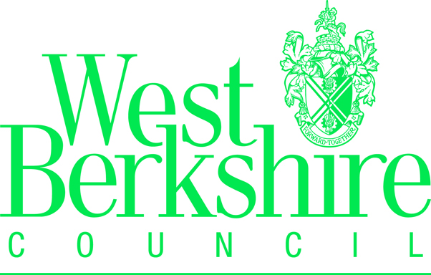

HOUSING / COUNCIL TAX REDUCTION CHANGE OF CIRCUMSTANCES FORM

Name: ………………………………………………………… Claim No: …………………………………

Address: ……………………………………………………… Tel No: …………………………………

It is important you let us know of any changes in your circumstances. If you are receiving Pension Credits you do not need to tell us about changes but you must tell the Pension Service. You must tell us about any changes in your circumstances such as the following:

• You change your address.
• Your income, or the income of anyone who lives with you, goes up or down.
• Your savings or capital, or the savings or capital of anyone who lives with you, goes up or down.
• You, or anyone you live with, stop getting Income Support or income-based Jobseeker’s Allowance (including
if you become sick and produce medical evidence).
• You, or anyone you live with, start getting Income Support or income-based Jobseeker’s Allowance.
• You, or anyone you live with, start work or change jobs.
• You, or anyone you live with, go into hospital.
• Anyone joins or leaves your household (for example, the birth of a baby).
• You, or anyone you live with, start or leave full-time education.
• The rent you pay to a private landlord changes.

Use This Box to tell us the date of the change and what the change is.

Evidence of the change is also required, if you do not currently have evidence available to provide
to us, please continue to complete and return this form as soon as possible
and send the evidence to us later, once it is available.

Declaration

Please read this declaration carefully.

I understand the following.

• If I give information that is incorrect or incomplete you may take action against me, which could include court
action.
• You will use the information I have provided to change my claim for Housing Benefit or Council Tax Reduction, or
both. You may check some of the other information with other sources within the council, rent offices and
other councils.
• You may use any information I have provided in connection with this and any other claim for social security
benefits that I have made or may make. You may give some information to other government organisations,
if the law allows this.

I know I must let West Berkshire Council, Benefits section know about any further changes in my circumstances that might affect my claim. I understand that if I have knowingly provided false or incomplete information and fail to let you know about changes in my circumstances, I may be prosecuted. It is my responsibility to check any letters you send to me giving details of my assessment and must contact the Benefits section if anything is incorrect.

I declare the information I have given on this form is correct and complete.

Please confirm that you have read the above information by typing your name, today’s date and National Insurance Number below.

/ /
Date:
Your signature:

National Insurance
Number:

You must check all letters sent to you by the Benefits Section and advise us immediately if any of your circumstances appear to be incorrectly stated.

You must advise West Berkshire Council, Benefits Section, of any changes in your circumstances as soon as they occur, to prevent overpayments and ensure that you receive your full entitlement to Housing and/or Council Tax Reduction.

