 |  | The Assessment Framework  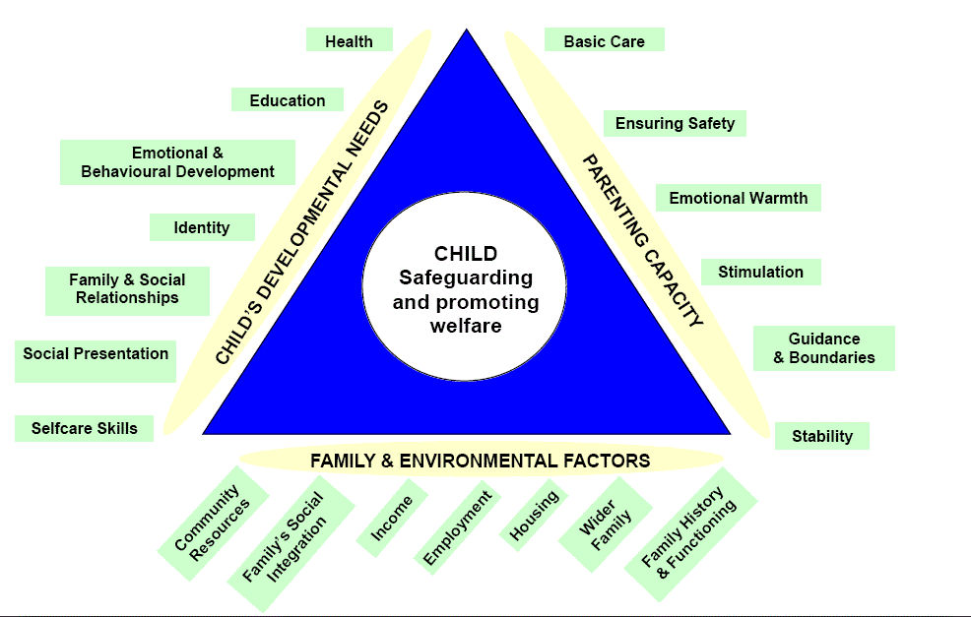
 | Multi-Agency Report
 | for
 | Child Protection Conference

Notes for use: If you are completing the form electronically, the text boxes will expand to fit your text.
If there are not enough boxes in any section, continue on a separate sheet or on an extra CAF form.
The completed form contains personal data to be protected and processed in line with the Data Protection Act 1998.

Identifying details: |  |  | Date of Report:
Child |  |  | Worker
Forename(s) |  |  | Name
Surname |  |  | Role
Date of Birth |  |  | Agency

An overview of your involvement with child/family.
AND

Your observations of the child and their daily life… their wishes and feelings, their demeanour, their routine, their interaction with family, peers, professionals

When things are safe enough, what will you observe different to what you have described above?
What can you contribute to a plan to keep the child safe?

Breakdown of information for conference:
Dangers/Risks  (what do you consider is placing the child at risk of significant harm) |  |  | Safety  (Factors that reduce the risks identified)
Complicating Factors  (what factors contribute to difficulty for the child) |  |  | Strengths  (positive resources in the family)
Grey Areas
(areas of uncertainty)
Signature of person completing the report: |  | ……………………………………………………………
*Signatures of those with legal Parental Responsibility who have viewed the report: |  | ……………………………………………………………  ……………………………………………………………  ……………………………………………………………  Date:
Comments:
Berkshire’s Child Protection Procedures (www.proceduresonline.com/Berks)

It is the responsibility of all agencies who have participated in the enquiry or who have relevant information to make this available to the conference in the form of a written, legible and signed report. The report should be provided to parents and children when appropriate at least 48 hours in advance of initial conferences and 5 working days before review conferences. The report should be provided to the Chair at least 24 hours prior to initial conferences and 3 working days in advance of the review conference.

